21 September 2018

PRACTICAL ARRANGEMENTS

The 20th Meeting of the IRDR Scientific Committee
Chengdu, China
15 October 2018
International Conference on
Integrated Science & Technology Contributions for Informed National Policy-Making and Action for the Implementation of the Sendai Framework
16-17 October 2018
Field Trip
18 October 2018

1. VENUE
Institute of Mountain Hazards and Environment (IMHE), Chinese Academy of Sciences
#.9, Block 4 , Renminnanlu Road, Chengdu,China
WIFI will be available at the meeting room.

2. Hotel
Ascott Raffles City Chengdu
No. 3, Section 4, South Remin Road Wuhou District, Chengdu 610041 China
Tel: +86 28 6268 2888
https://www.the-ascott.com
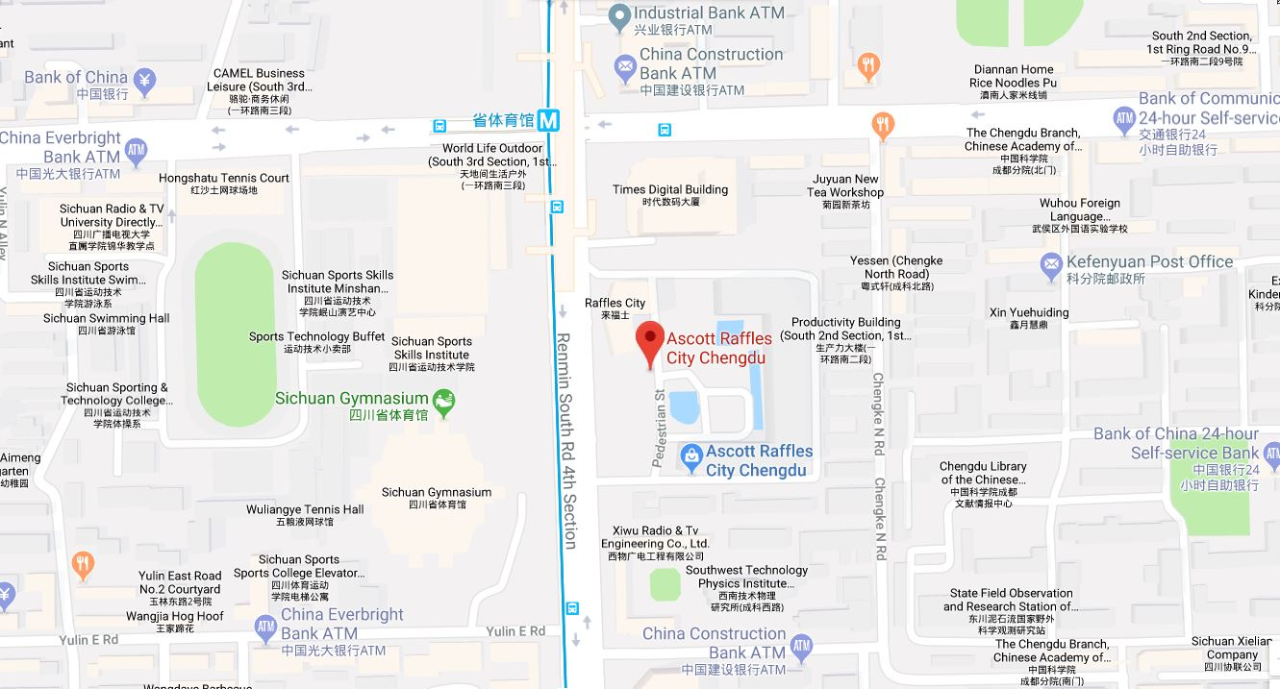
Useful information about the hotel:
- Check in time: 14:00 (early check in will be possible if the room is available)
- Check out time: 12:00
- 500 CNY/room.night or equivalent foreign currency (USD/EURO/GBP/JPY) deposit will be taken when check in. Credit card preauthorization is recommended.
- The Hotel offers complimentary breakfast, and WIFI as parts of the accommodation package.
- Concierge in Hotel lobby speaks good English and may help to call taxi upon request.
- The hotel is walking distance to the meeting venue.

3. TRAVEL
IRDR IPO will cover the travel cost of the SC members, including an economy class (most direct route) round ticket, hotel accommodation, local transportation, partial per diem and other travel related expenses according to the travel rules.

- REIMBURSEMENT
Please note that you will be get reimbursed by cash (CNY) during the meeting. Please well-kept and bring all your original receipts including the boarding pass, visa fee receipt, etc.; and fill in the travel claim form (See Annex). IPO will collect the original travel receipts on 15 October 2018. Payment cannot be made without ORIGINAL receipts or tickets for all expenses claimed. IRDR IPO cannot guarantee reimbursement when loss of the original receipts (scanned copy of the receipts are not accepted by finance).

- Meals
- Breakfasts are included in the hotel rate.
- Boxed lunches (Regular meals and vegetarian diet) will be provided at the meeting room.
- Reception on 15th and 16th April will be arranged at the local restaurant (walking distance).

- Local transportation
- Airport transportation
Please follow the sign at the Airport to the Taxi Waiting Area. Here is the note to the taxi driver:
请送我去：成都雅诗阁来福士
地址：成都市武侯区人民南路四段三号来福士广场T3雅诗阁
电话：028 62682888
From the Airport to the hotel, the distance is 17km or so. It normally takes 30-40 minutes by taxi, and cost roughly 50 CNY.

7. ELECTRICITY
- The electricity in China is generally 220V, 50HZ, AC. Please be wary about plugging in your electronic equipment which may be designed to handle a lower or higher voltage.

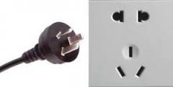

8. Currency
The currency in China is the Chinese Renminbi (CNY)
- Automatic Teller Machines (ATMs) are very common throughout towns in Beijing as well as the airport.
- MasterCard and Visa are accepted easily at all ATMS, and most of shops and restaurants. Please be aware that some local shops and restaurants may only accept cash, however the electronic payment is very common, like Alipay and Wechat.
- Foreign currency exchanges: can be made at Chengdu Shuangliu International Airport or any banks in town with your passport.

9. PHONE
Most overseas Sim cards work in China however must apply international roaming function before your departure.

10. WeaTHER
It is early autumn weather of Chengdu in October. Whilst the average high temperature is 21°C (70°F), the average low is 15°C (59°F). October proves to be the best month to visit Chengdu due to its comfortable weather for outdoor activities. However, visitors are reminded that the variation of temperature during the day and night could be quite substantial, especially in the mountainous area. The variation there could be like 20°C (68°F) during the day and 5°C (41°F) at night.

11. EMERGENCY CONTACT NUMBERS
If you need to get in contact with someone concerning matters related to the meeting logistics, please use the numbers below:
LANG Lang Mobile: +86 1760 1600 998
HAN Qunli Mobile: +86 1360 1115 414

TRAVEL CLAIM FORM

Turquoise shaded areas are for IRDR use only.


Name of participant:

Title of meeting:
Place & dates:
Email of participant:

To be submitted no later than 1 month after the meeting (only one meeting per form).
IRDR IPO cannot guarantee reimbursement when loss of the original receipts during the delivery by unregistered mail.

I declare that the expenses claimed below are not being reimbursed from any other source.

Signature

Date:

BANK REFERENCES

Bank transfer in …currency ☐

Name & address of account holder:

Bank, name branch & full address:

IBAN (for European countries only) ....................................................................................

Swift code/BIC: | ABA/Routing n°  …………………………………… |  | Bank/sort code  ……………………………
Account n:

TRAVEL EXPENSES

 |  |  |  |  |  |  |  |  |  | Amount |  |  |  |  |  | Currency |  |  |  |  | Internal use only
By air: (tourist/economy class airfare using most economical fare available):  By rail:  (Do not fill in this part if you received a prepaid ticket) |  |  |  |  |  |  |  |  |  |  |  |  |  |  |  |  |  |  |  |  | Prepaid
Local transportation (taxi, bus, etc.):

Other Expenses (please detail):

By road (indicate how many kms):
Total amount travel
SUBSISTENCE
Arrival date / /2018 |  |  |  |  |  |  |  |  |  |  | Departure date / /2018
Accommodation  (fill in only if hotel not paid by sponsor) |  |  |  |  |  |  |  |  |  |  | Amount paid |  |  |  |  |  |  | Currency |  |  | IRDR use only
Number of nights:
Meals not paid by sponsor (please tick for meals you paid yourself):
Date |  | / |  | / |  | / |  | / |  |  |  | / |  |  | / |  |  |  | / | /
Breakfast*
Lunch
Dinner
Per diem rate % |  | % |  | % |  | % |  | % |  |  |  | % |  |  | % |  |  |  | % | %
Amount per day
Total Amount Subsistence
Sundries
*If not included in hotel bill
 |  |  |  |  |  |  |  |  | TOTAL CLAIM
Checked by: Travel approved by IRDR staff member:

