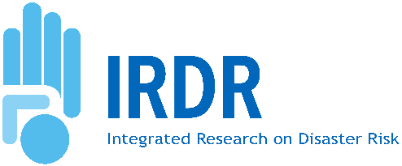

2026 IRDR Young Scientists Lumos (5th)
UTC 7:00-8:30, 7 April 2026, Online
Economics of Disasters and Climate Change: Addressing inequalities, injustices, marginalisation and vulnerabilities
Concept Note
- Rationale
In order to enhance the connection and promote the innovations and actions of young scientists, IRDR IPO designs a mechanism of “IRDR Young Scientists Lumos”, which will be webinars, sessions, meetings, or discussions mainly organised and participated by young scientists and young professionals in the global disaster risk reduction (DRR) community.
Disasters and climate change are not experienced equally across societies. Increasing evidence demonstrates that disaster risks are shaped by structural inequalities, socio-economic disparities, governance gaps, and historical patterns of marginalisation. Understanding the economics of disasters and climate change is therefore essential for revealing how risk, loss, and recovery are distributed, how incentives and policy instruments shape resilience outcomes, and how economic systems can either reinforce or reduce inequalities and injustices. In the new global DRR research agenda “A Framework for Global Science in Support of Risk-informed Sustainable Development and Planetary Health”, which was adopted by ISC, UNDRR and IRDR, the Priority 2 “Addressing inequalities, injustices, marginalisation and vulnerabilities” calls for advancing knowledge on the social construction and distribution of risk and promoting inclusive, equitable approaches to risk reduction and climate action.
Aligned with the IRDR Young Scientists Programme’s mission to amplify youth-led contributions to DRR, this session will:
- Highlight emerging research on the economic drivers and consequences of disaster risk and climate change.
- Examine how inequalities and vulnerabilities are produced, reinforced, or reduced through economic systems and policy choices.
It is expected that through the discussion, the innovation cases from young professionals will be visualised and acknowledged by the global DRR community.
- Agenda
It will be a 90-minute online workshop. 3-4 young professionals from different regions will be invited to share their cases. Leading scientists and experts will be invited to give a keynote speech and provide comments and suggestions. There will be 30 minutes of discussion for all participants.
Item 1: Keynote (10 minutes)
- Professor Ilan Noy
Item 2: Presentations by young researchers (8 minutes each)
Item 3: Q&A and discussions
- Organisers
This Lumos will be organised by IRDR with the support of other partners.
- Call for Presentations
This lumos call for two presentations delivered by young researchers. Applicants will be required to submit:
- A short abstract (250 words max)
- A brief biography (100 words)
- Contact information
Application deadline: 29 March, 2026
Selection notification: 1April, 2026
- Registration and Meeting Link
Registration Link: https://zoom.us/webinar/register/WN_KnWc3TSbRRGRbmUKAbweDA
Open to all researchers, practitioners, students, and community members interested in Indigenous knowledge and DRR. Registration will be free and accessible online.

Lumos: a wand-light charm in Harry Potter series. This charm is used to create light and reveal hidden things. Lumos here means that the young scientists create innovations and generate the impacts to the world.

