Integrating Disaster Risk Reduction and the Sustainable Development Goals: Global and Regional Loss Mechanisms, Trade-offs, and Policy Pathways

1. Introduction
Complex interconnections exist between disaster loss and the Sustainable Development Goals (SDGs). Disasters can threaten development gains and slow progress toward achieving the SDGs. Vulnerable populations and socio-economic systems often suffer disproportionate losses, posing substantial challenges to sustainable development worldwide [1]. As disasters continue to occur with increasing frequency and intensity under global environmental change, understanding the relationships between disaster losses and SDG progress at the global scale has become increasingly important. Investigating these relationships can help identify the synergies and trade-offs between disaster risk reduction (DRR) and sustainable development, thereby providing scientific support for enhancing global resilience and promoting sustainable economic and social development.

2. Data and Methodology

2.1 Data

2.1.1 SDG Data Source and Processing
The Sustainable Development Goal (SDG) data used in this study were extracted from the 2025 Sustainable Development Report database released by the United Nations Sustainable Development Solutions Network (UN SDSN). The dataset contains a total of 126 SDG indicators covering all 17 SDGs, including 102 national-level indicators worldwide. The research period spans from 2000 to 2025 with annual observations.
The SDG indicators integrate both official and unofficial data sources. Approximately two-thirds of the data are obtained from authoritative international organizations, including the World Bank, OECD, WHO, FAO, ILO, and UNICEF. The remaining one-third derive from non-traditional statistical sources such as household surveys and civil society networks, including Oxfam, the Tax Justice Network, the World Justice Project, and Reporters Without Borders, and other sources [3-4]. Data extraction from the 2025 SDSN report was conducted between March and April 2025.
Following the regional classification standards of the United Nations Office for Disaster Risk Reduction (UNDRR), national-level SDG data were aggregated to construct time-series indicators for the Asia-Pacific region. The compiled regional SDG dataset serves as the foundation for subsequent correlation and causality analysis between SDG performance and disaster loss indicators.

2.1.2 Disaster Loss Data Source and Processing
Disaster data were obtained from the EM-DAT International Disaster Database (Emergency Events Database), maintained by the Centre for Disaster Epidemiology Research (CRED) at KU Leuven, Belgium. EM-DAT has recorded more than 26,000 major disaster events across 231 countries and regions globally since 1900[5].
This study collected all global disaster records from 2000 to 2025 via the official EM-DAT website. In line with the UNDRR’s regional criteria, disaster loss records for the Asia-Pacific region were filtered from the global dataset. Two core variables were selected to measure disaster impact, including Total Affected Population and Total Adjusted Economic Damage (constant US dollars).

The annual average disaster impact was calculated following the formula:
- Average Annual Affected Population / Economic Loss = Annual sum of affected population or economic losses from all disasters in the Asia-Pacific region ÷ Total number of disaster records in the corresponding year

2.1.3 Classification of Disaster Loss Indicators
Disaster losses are assessed through four categories of indicators: total average disaster-related affected population; single-hazard-related affected population; total average disaster-related economic loss; and single-hazard-related economic loss.
Single-hazard analysis focuses on the primary disaster types affecting the global level and the Asia-Pacific region, respectively: flood, earthquake and wildfire for the analysis between affected populations and the SDGs at the global level; storm, flood and drought for the analysis between economic loss and the SDGs at the global level; flood, extreme temperature and earthquake for the analysis between affected population and the SDGs in the Asia-Pacific region; and flood, storm and earthquake for the analysis between economic loss and the SDGs in the Asia-Pacific region.
The SEM analysis includes floods, earthquakes, storms, droughts, extreme temperatures, and mass movement events.
Null values were excluded during calculation. Finally, annual average affected population and average economic loss data for the Asia-Pacific region from 2000 to 2025 were generated.
  - Method
This study explores the relationships between disaster losses and SDG performance in the Asia-Pacific region using three integrated methods: (1) Spearman correlation analysis; (2) Transfer entropy analysis; and (3) Structural equation modeling (SEM). The analytical framework is designed to identify statistical associations, directional interactions, and potential transmission mechanisms between disaster losses and SDG indicators (Figure 1).
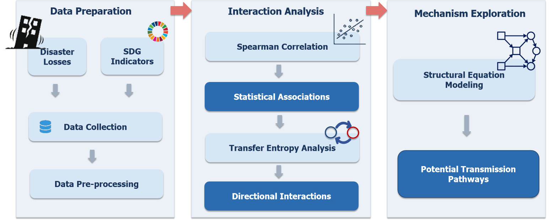
Figure 1. Technical framework diagram
    - Spearman Rank Correlation Analysis
Spearman rank correlation was applied to examine the monotonic relationships between annual average disaster-affected population, average economic loss, and various SDG indicators in the Asia-Pacific region. The method calculates the rank correlation coefficient (rho), ranging from −1 to 1, to reflect the strength and direction of monotonic associations between variables. The data preprocessing procedures is as follows:
(1) Separate datasets of disaster losses and annual SDG indicators were imported.
(2) Datasets were merged by year, retaining only overlapping annual observations.
(3) The SDG indicators containing null values were eliminated.
(4) Only time-series pairs with more than 15 valid years were included in correlation testing. Correlation coefficients and corresponding p-values were computed to identify significant relationships. Indicator pairs with p < 0.1 were retained as statistically significant.
(5) Standardization of indicator direction: all SDG indicators were classified into positive and negative types. For the positive indicators, a higher value represents better sustainable development performance. While for the negative indicators, a lower value indicates fewer risks and better development outcomes. To unify evaluation logic, the original coefficients of positive indicators remained unchanged, while the signs of negative indicator coefficients were inverted. After correction, all indicators follow a unified standard: higher values indicate better development trends. For the corrected coefficients, positive value means that disaster losses and sustainable development move in the same direction (synergy) and negative value means that disaster losses and sustainable development move in opposite directions (trade-off).

2.2.2 Transfer Entropy Analysis
Transfer Entropy (TE) was adopted to detect causal linkages and directional information flow between disaster loss indicators and SDG indicators. Based on information entropy theory, transfer entropy can identify directed driving relationships in time-series data and quantify the predictive contribution of one variable to another [6-7].
For significant correlated pairs (p < 0.1) screened from the correlation analysis: (1) Annual time-series data of disaster losses and SDG indicators were matched year by year. (2) Observations with missing SDG values were removed. (3) Only time-series with more than 15 valid years were included. Bidirectional transfer entropy values were calculated: including information flow from Disaster to SDG and information flow from SDG to Disaster. A larger TE value indicates stronger information transmission and greater driving influence in that direction. This approach distinguishes dominant influencing factors from passive responding factors and clarifies the dynamic causal logic between disaster impacts and SDG performance. Based on comparative TE values: higher TE from the SDGs to disasters means the SDG development level dominates and affects the degree of disaster exposure. Higher TE from disasters to the SDGs means disaster fluctuations act as the dominant factor and significantly influence regional sustainable development levels.

2.2.3 Structural Equation Modeling
Structural equation modeling (SEM) was employed to explore the complex transmission pathways between SDG indicators and disaster losses (affected population and economic damage), and to quantify both direct and indirect effects within the system. While the TE analysis identifies the direction and relative strength of pairwise information flow between variables, it does not explicitly disentangle multivariate interactions or mediation mechanisms. Therefore, SEM was introduced as a complementary approach to further quantify how multiple drivers jointly influence disaster impacts through interconnected pathways.
The SEM framework consists of both measurement and structural components [8]. The measurement model defines the relationships between latent constructs representing SDGs and disaster impact domains, and their observed indicators, ensuring that each latent variable is appropriately represented. The structural model specifies the hypothesized directional relationships among latent variables, including pathways from SDG indicators to disaster loss variables and associated indirect effects.
Based on the identified dominant influencing factors in TE analysis, Partial Least Squares Path Modeling (PLS-PM) was implemented using the R package “seminr”. Compared with conventional covariance-based SEM, PLS-PM requires smaller sample sizes and imposes fewer distributional assumptions, making it more suitable for the present study’s data characteristics and exploratory causal structure [9-10]. Path coefficients were estimated using the PLS algorithm with a path-weighting scheme, and their significance was assessed via bootstrap resampling (n = 1000).

3. Results for the Global System

3.1 The interaction between economic loss and the SDGs
This section examines the relationship between economic loss from disasters and the SDGs implementations at the global level. The analysis covers the total average economic losses from disasters, and the hazard-specific economic losses, such as storm, flood and drought.

3.1.1 Total average economic loss and the SDGs
For the total average economic losses caused by global disasters, 40 out of 44 indicators showed that the feedback effect of implementing the SDGs (TE value of 0.81) in reducing global disaster economic losses was significantly greater than the impact of total disaster economic losses on the SDGs (TE value of 0.50). They show a predominantly negative trade-off effect overall. This indicates that as the economy and society develop rapidly, the exposure risk of disaster economic losses is also increasing. The indicator with the highest TE difference was sdg2_obesity (Prevalence of obesity), sdg5_familypl (Demand for family planning satisfied by modern methods), sdg5_edat (Ratio of female-to-male mean years of education received), sdg5_lfpr (Ratio of female-to-male labor force participation rate), sdg5_parl (Seats held by women in national parliament), sdg9_intuse (Population using the internet), and sdg15_cpfa (Mean area protected in freshwater sites important to biodiversity). The TE difference for all of these indicators was 0.61 (Figure 2-4). The results show that at the global level, gender equality (SDG5), internet penetration rate (SDG9) and freshwater biodiversity protection (SDG15) have a relatively clear trade-off effect in reducing disaster economic losses.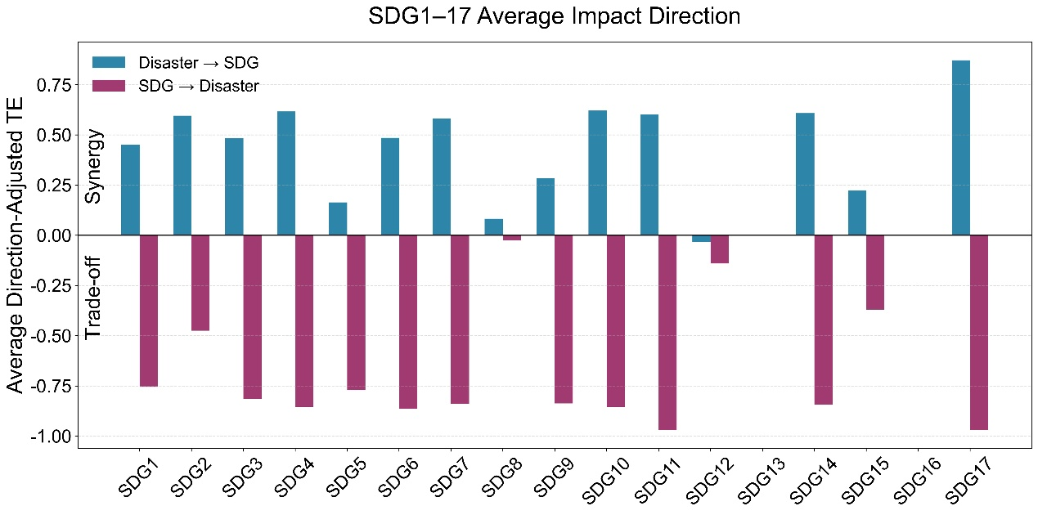
Figure 2. The bi-directional impact between the total average economic loss and the SDGs at the goal level in the global system

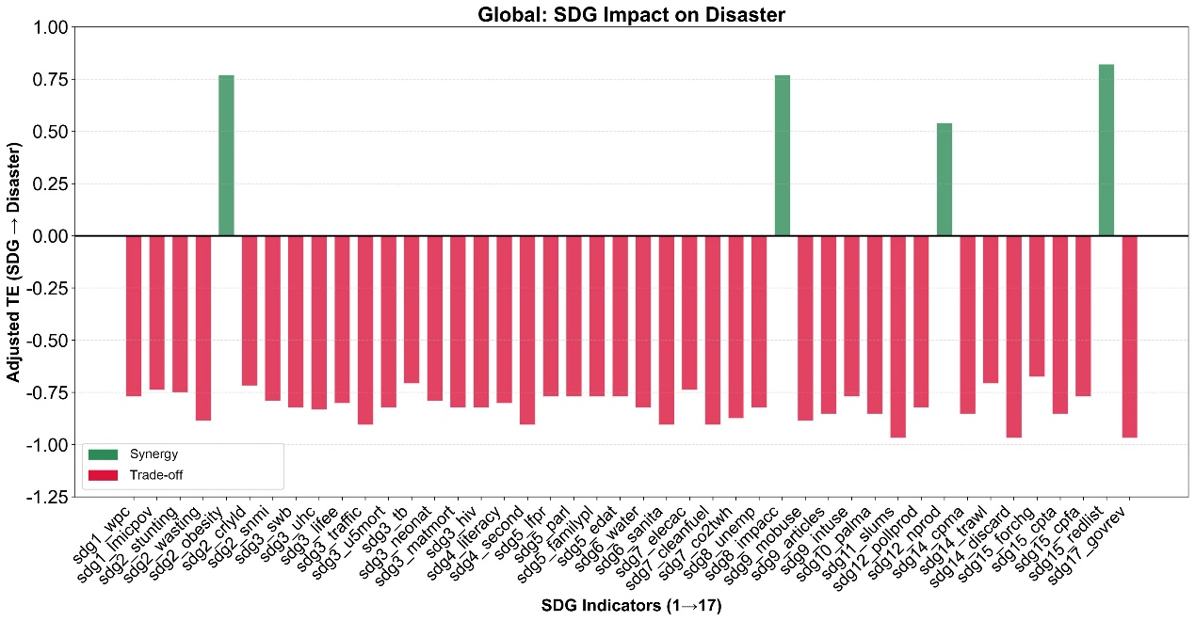
Figure 3. The impact of the SDGs on the total average economic loss at the indicator level in the global system

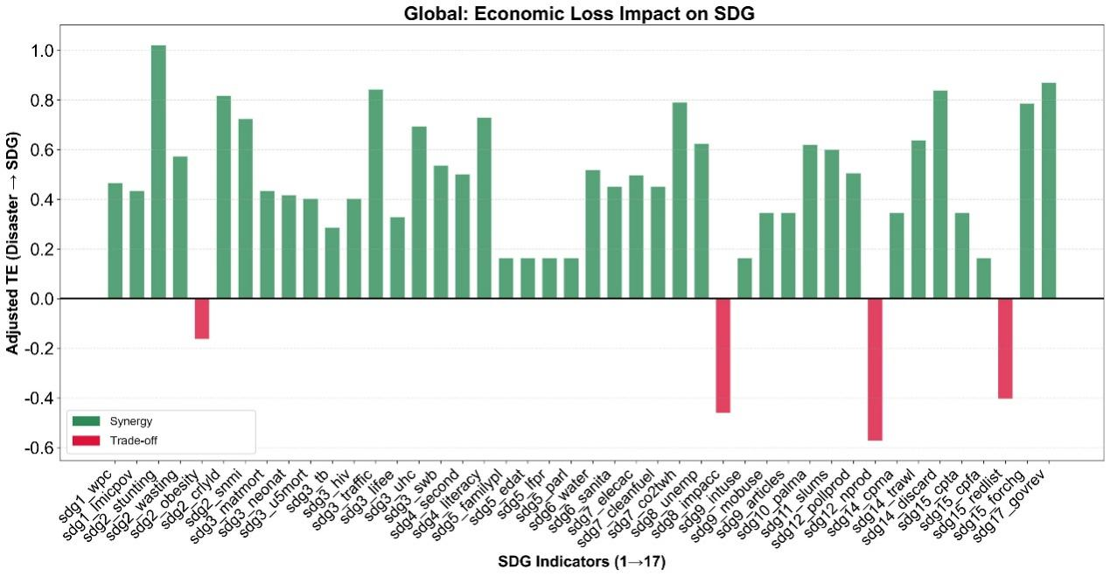
Figure 4. The impact of the total average economic loss on the SDGs at the indicator level in the global system

3.1.2 The storm-related affected population and the SDGs
In terms of the economic losses caused by global storm disasters, 41 out of 47 indicators showed the feedback effect of the implementation of SDGs (TE value of 0.74) in reducing the economic losses from global storm disasters is significantly greater than the impact of storm disaster economic losses on SDGs (TE value of 0.46). Overall, they show a negative trade-off effect on reducing the economic losses. It indicates that with the rapid development of the economy and society, the exposure risk of global storm disaster economic losses is also increasing. The TE difference is the highest for sdg12_pollprod (Production-based air pollution), sdg9_articles (Articles published in academic journals), sdg14_cpma (Mean area protected in marine sites important to biodiversity), and sdg15_cpta (Mean area protected in terrestrial sites important to biodiversity), with TE differences of 0.60, 0.49, 0.49, and 0.49 respectively (Figure 5-7). At the global level, the production-based air pollution (SDG12), academic journal publications (SDG9), marine biodiversity protection (SDG14), and terrestrial biodiversity protection (SDG15) all have a relatively obvious trade-off with reducing the economic losses from storm disasters.
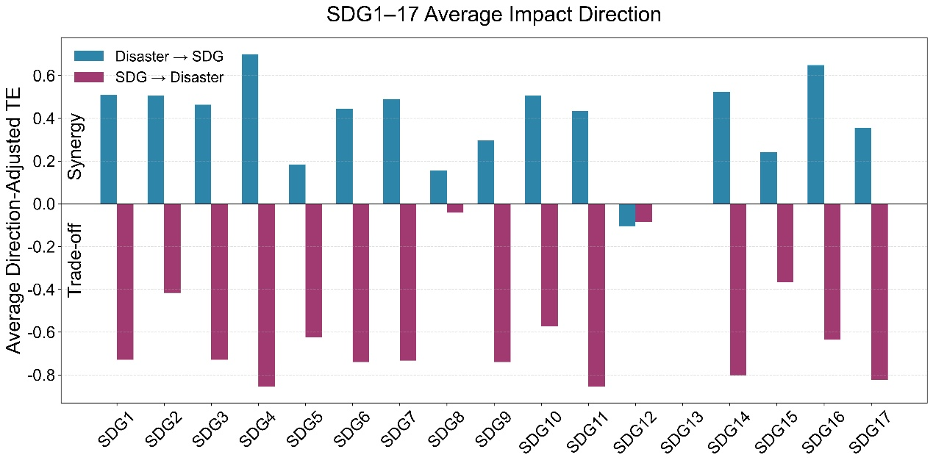
Figure 5. The bi-directional impact between the storm-related affected population and the SDGs at the goal level in the global system
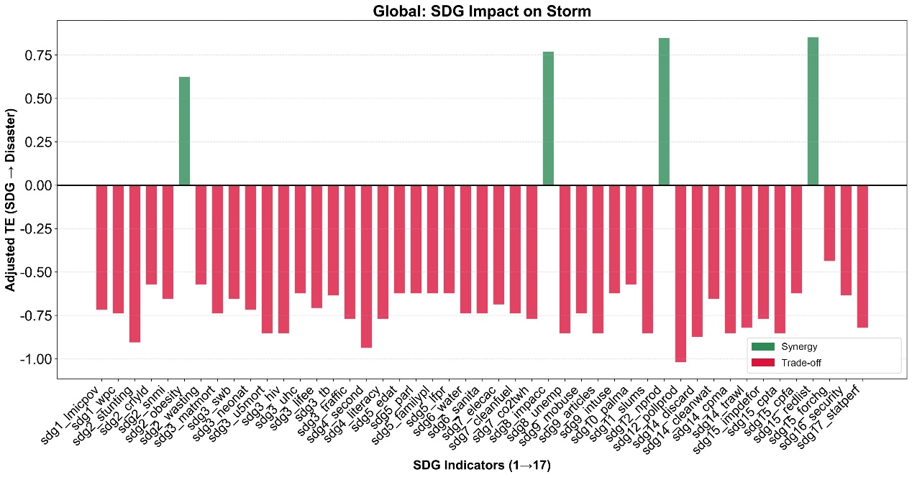
Figure 6. The impact of the SDGs on the storm-related affected population at the indicator level in the global system

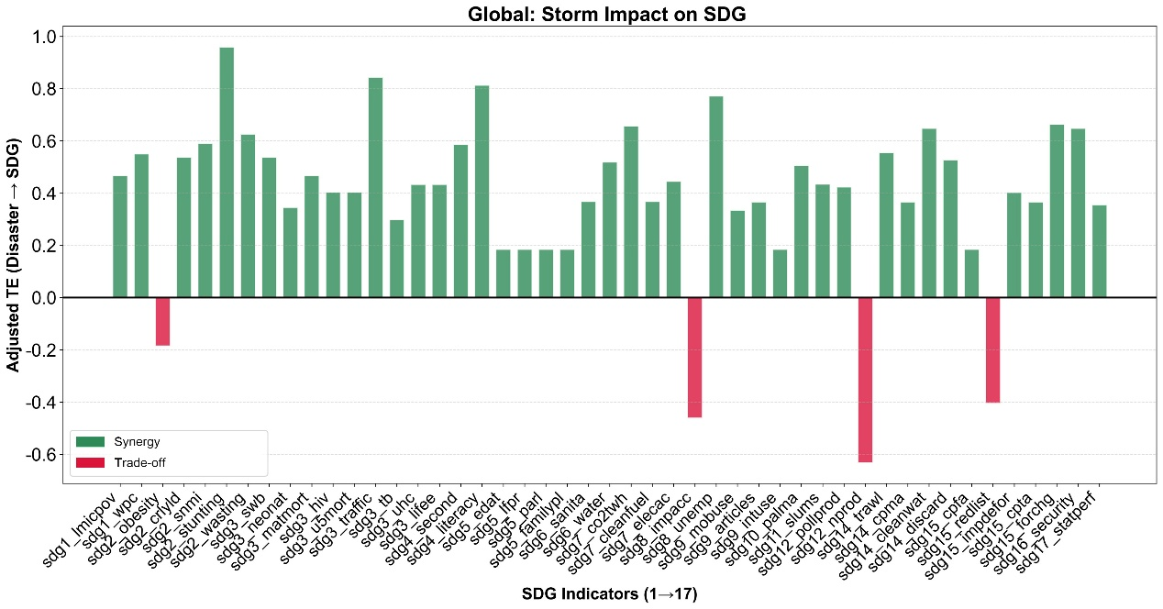
Figure 7. The impact of the storm-related affected population on the SDGs at the indicator level in the global system

3.1.3 The flood-related affected population and the SDGs
For the economic losses caused by global floods, 52 out of 53 indicators showed that the feedback effect of implementing the SDGs (TE value of 0.87) in reducing the economic losses from global floods was significantly greater than the impact of flood disaster losses on the SDGs (TE value of 0.45). Overall, they mainly show a negative trade-off effect on reducing the economic loss. It indicates that with the rapid development of the economy and society, the exposure risk of flood disaster losses is also increasing. The indicator with the highest TE difference was sdg3_ncds (Age-standardized death rate due to cardiovascular disease, cancer, diabetes, or chronic respiratory disease in adults aged 30 to 70 years), sdg15_redlist (Red List Index of species survival), sdg3_u5mort (Mortality rate, under-5), and sdg3_hiv (New HIV infections), with TE differences of 0.69, 0.65, 0.65, and 0.65 respectively (Figure 8-10). At the global level, there is a relatively obvious trade-off between public health (SDG3) and reducing the economic losses from flood.
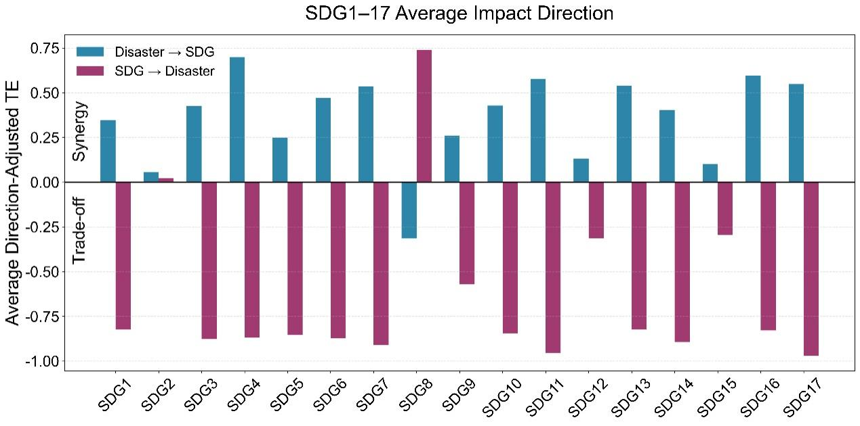
Figure 8. The bi-directional impact between the flood-related affected population and the SDGs at the goal level in the global system

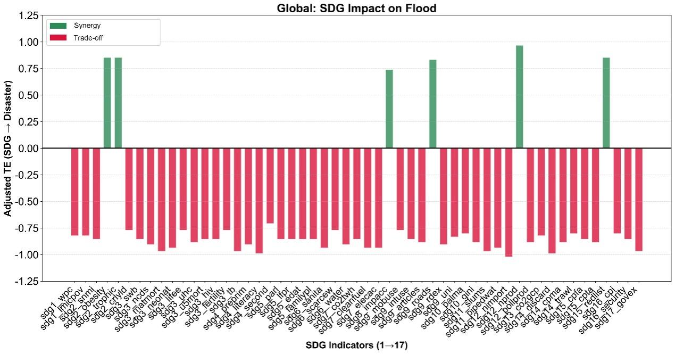
Figure 9. The impact of the SDGs on the flood-related affected population at the indicator level in the global system

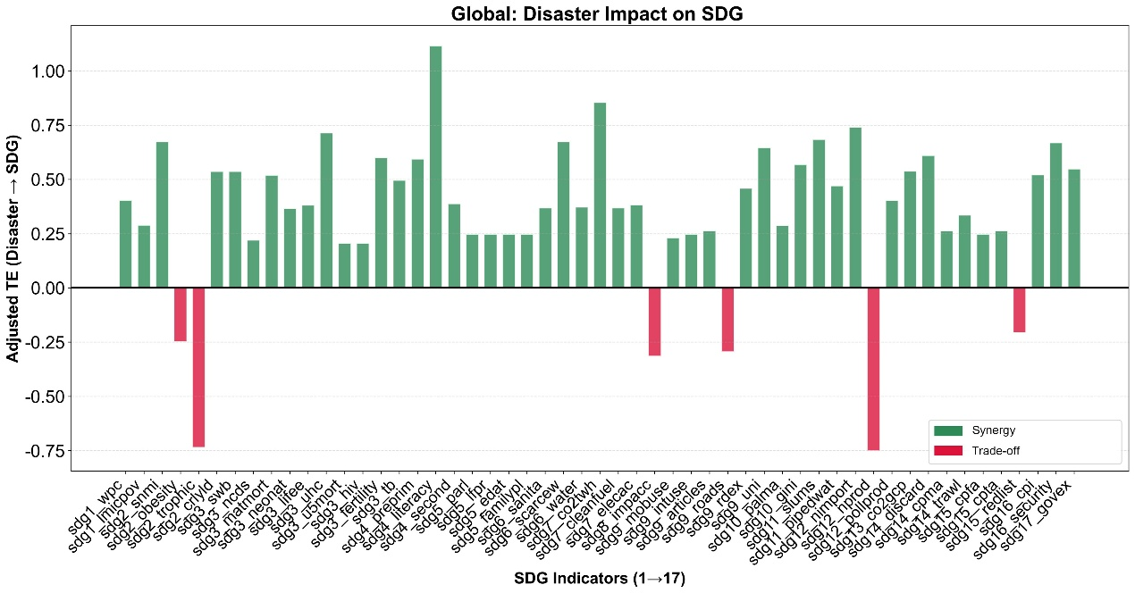
Figure 10. The impact of the flood-related affected population on the SDGs at the indicator level in the global system

3.1.4 The drought-related affected population and the SDGs
In terms of the economic losses caused by global drought disasters, 49 out of 55 indicators showed the feedback effect of the implementation of SDGs (TE value of 0.87) in reducing the economic losses from drought disasters was significantly greater than the impact of drought disaster losses on SDGs (TE value of 0.51). Overall, they show a negative trade-off effect on reducing the economic losses. It indicates that with the rapid development of the economy and society, the exposure risk of economic losses from drought is also increasing. The indicator with the highest TE difference was sdg6_sanita (Population using at least basic sanitation services), sdg7_cleanfuel (Population with access to clean fuels and cooking technology), sdg3_u5mort (Mortality rate under-5), sdg15_redlist (Red List Index of species survival), and sdg3_hiv (New HIV infections). The TE difference for all of these indicators was 0.66 (Figure 11-13). At the global level, the proportion of basic health services (SDG6), the proportion of the population with access to clean fuels and cooking technology (SDG7), and public health (SDG3) have a relatively obvious trade-off with reducing the economic losses from drought disasters.
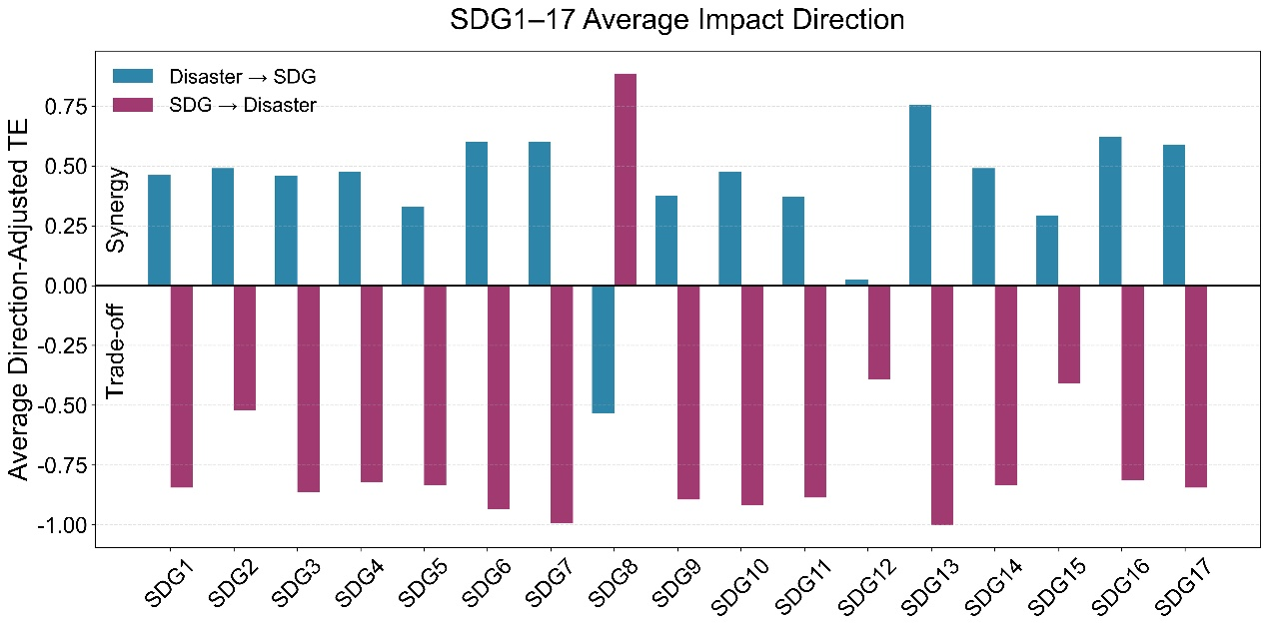
Figure 11. The bi-directional impact between the drought-related affected population and the SDGs at the goal level in the global system

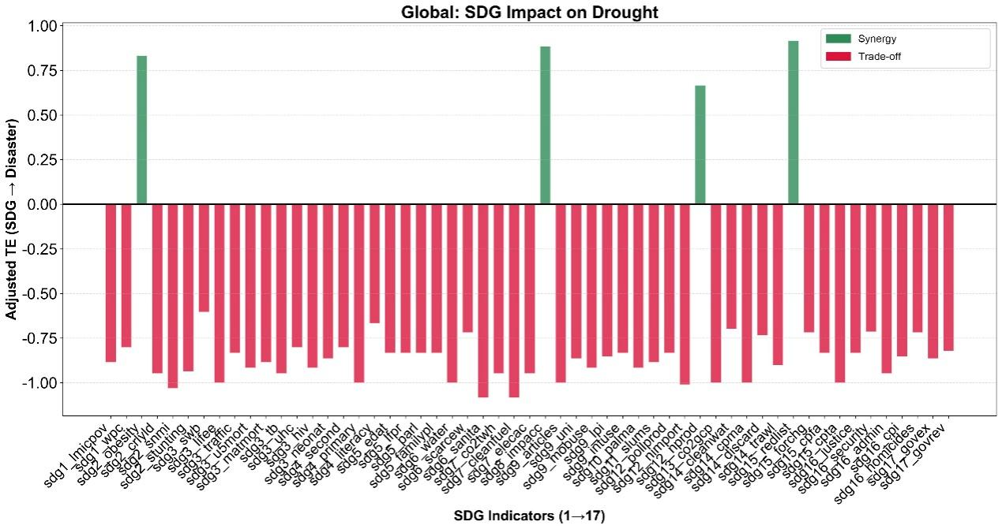
Figure 12. The impact of the SDGs on the drought-related affected population at the indicator level in the global system

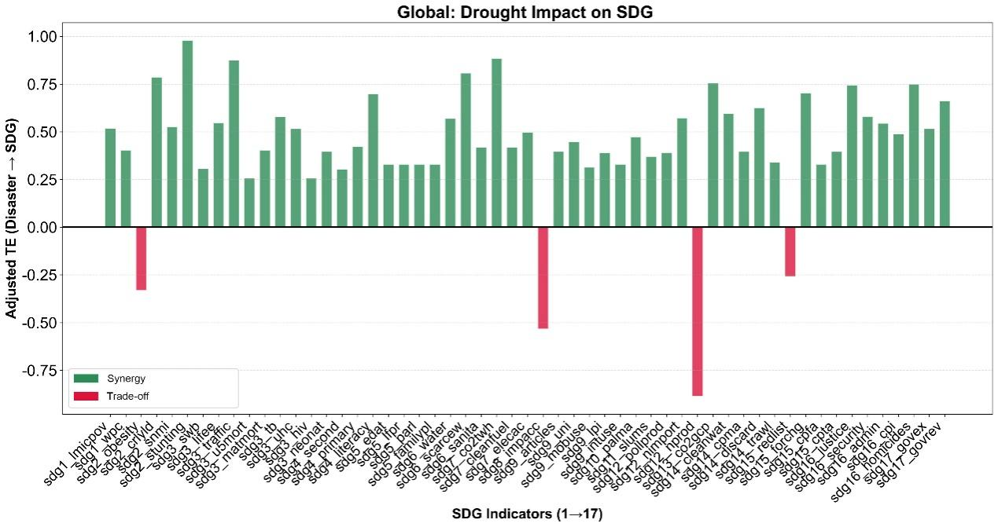
Figure 13. The impact of the drought-related affected population on the SDGs at the indicator level in the global system

3.2 The interaction between affected population and the SDGs
This section exams the relationship between disaster-related affected population and the SDGs implementations at the global level. The analysis covers the total average disaster-related affected population, as well as the hazard-specific affected population from flood, earthquake and wildfire.

3.2.1 The total average affected population and the SDGs
In terms of the total average number of affected people by global disasters, three SDGs indicators were detected. The synergetic feedback effect of the implementation of SDGs (TE value of 0.85) in reducing the number of disaster-affected people is significantly greater than the trade-off effect of disasters on SDGs (TE value of 0.55). The SDG indicator with the highest difference of the TE value is sdg17_statperf (Statistical Performance Index), with a TE difference of 0.46, indicating that the improvement of the national statistical capabilities (SDG17) plays an important role in reducing the number of disaster-affected people at the global level (Figure 14-16).
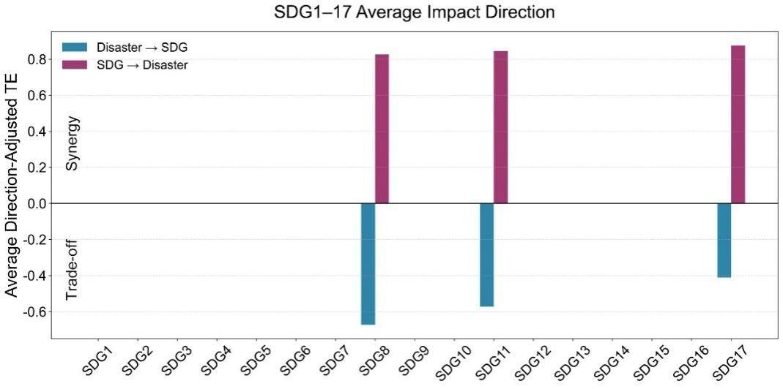
Figure 14. The bi-directional impact between the total average affected population and the SDGs at the goal level in the global system

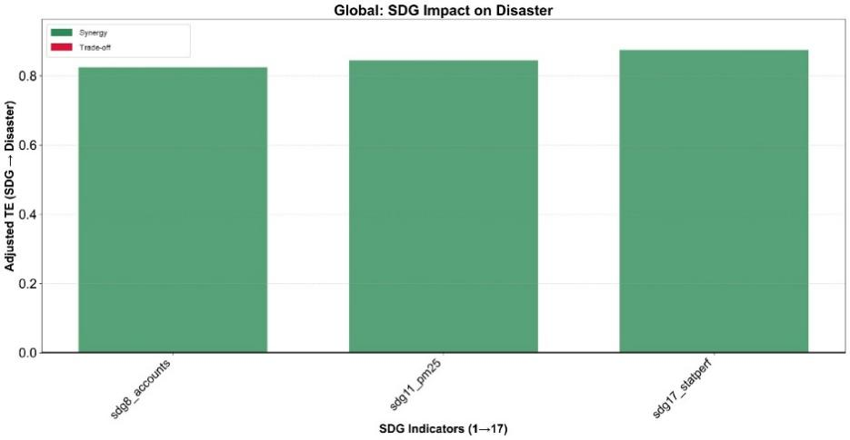
Figure 15. The impact of the SDGs on the total average affected population at the indicator level in the global system
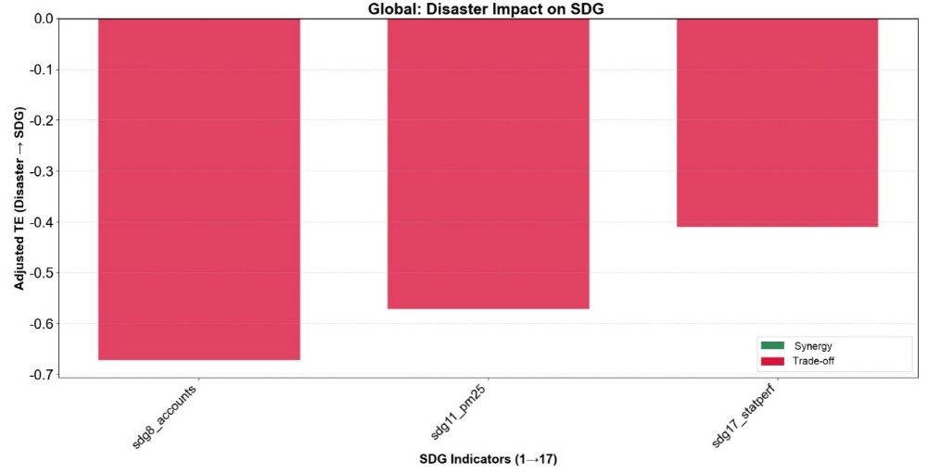
Figure 16. The impact of the total average affected population on the SDGs at the indicator level in the global system

3.2.2 The flood-related affected population and the SDGs
In terms of the number of people affected by global flood disasters, 55 out of 56 SDG indicators showed that the feedback effect of the implementation of SDGs (TE value of 0.86) in reducing the number of people affected by flood disasters was significantly greater than the impact of flood disasters on SDGs (TE value of 0.48). Overall, the SDG indicators show a positive synergy effect on reducing the affected population. The indicator with the highest TE difference was sdg2_snmi (Sustainable Nitrogen Management Index) and sdg6_sanita (Population using at least basic sanitation services), with a TE difference of 0.63 for both of them (Figure 17-19). This indicates that at the global scale, improving sustainable nitrogen management (SDG2) and enhancing the coverage of sanitation services (SDG6) are beneficial to reducing the number of people affected by flood disasters.
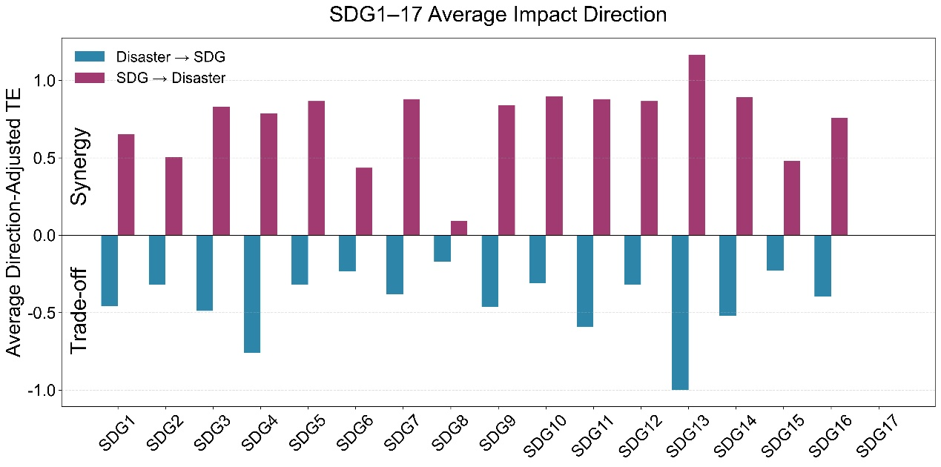
Figure 17. The bi-directional impact between the flood-related affected population and the SDGs at the goal level in the global system

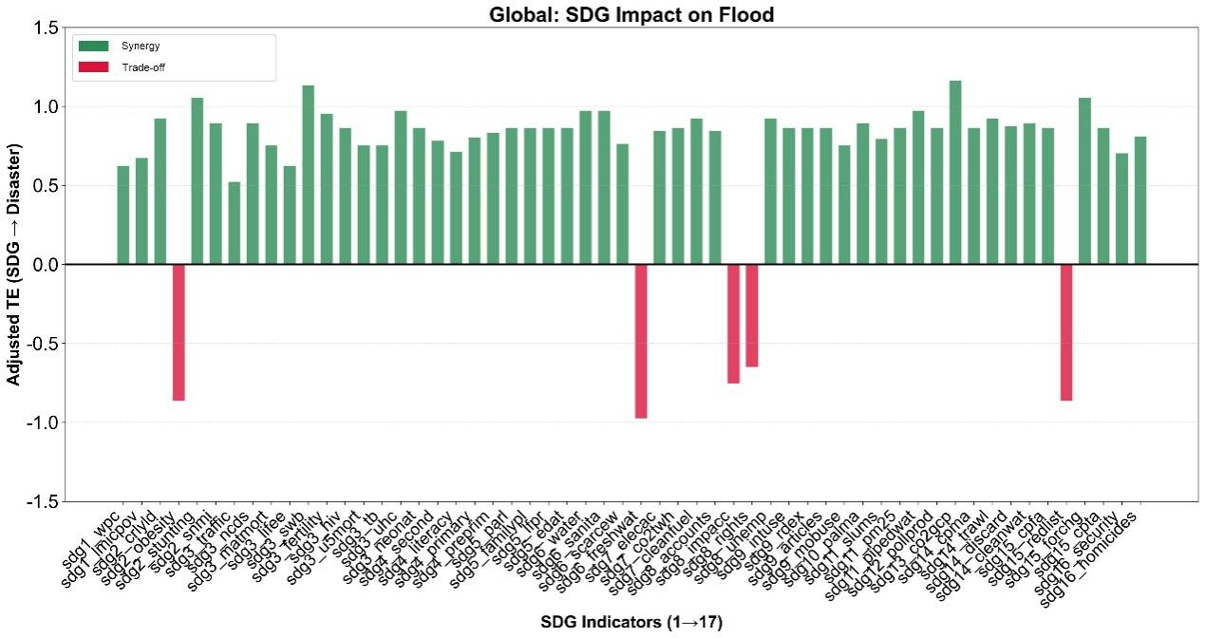
Figure 18. The impact of the SDGs on the flood-related affected population at the indicator level in the global system

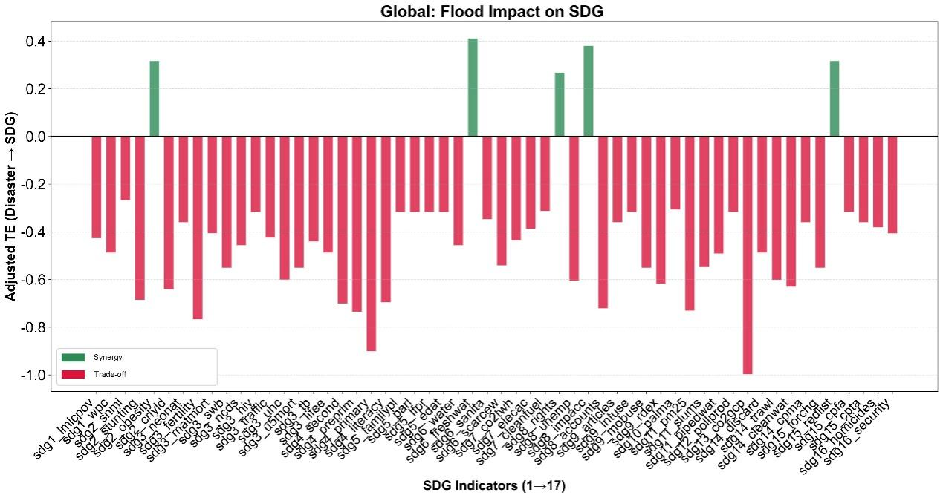
Figure 19. The impact of the flood-related affected population on the SDGs at the indicator level in the global system

3.2.3 The earthquake -related affected population and the SDGs
In terms of the number of people affected by global earthquake disasters, a total of 7 SDG indicators were detected, all of which showed that the feedback effect of SDGs implementation on reducing the number of people affected by flood disasters (TE value of 0.69) was significantly greater than the impact of floods on SDGs (TE value of 0.47). Overall, they show a positive synergy effect on reducing the affected population. The SDG indicators
with the highest TE difference is sdg17_statperf (Statistical Performance Index), with a TE difference of 0.38 (Figure 20-22). It indicates that at the global scale, the improvement of countries' statistical capabilities plays an important role in reducing the number of people affected by earthquake disasters.
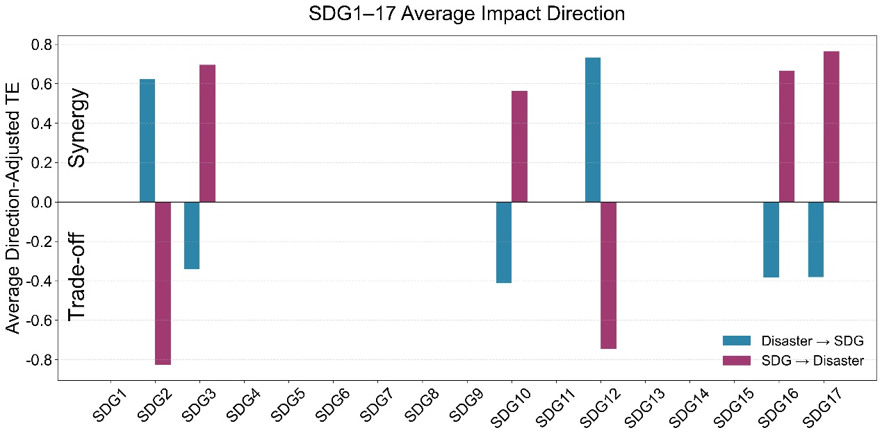
Figure 20. The bi-directional impact between the earthquake-related affected population and the SDGs at the goal level in the global system

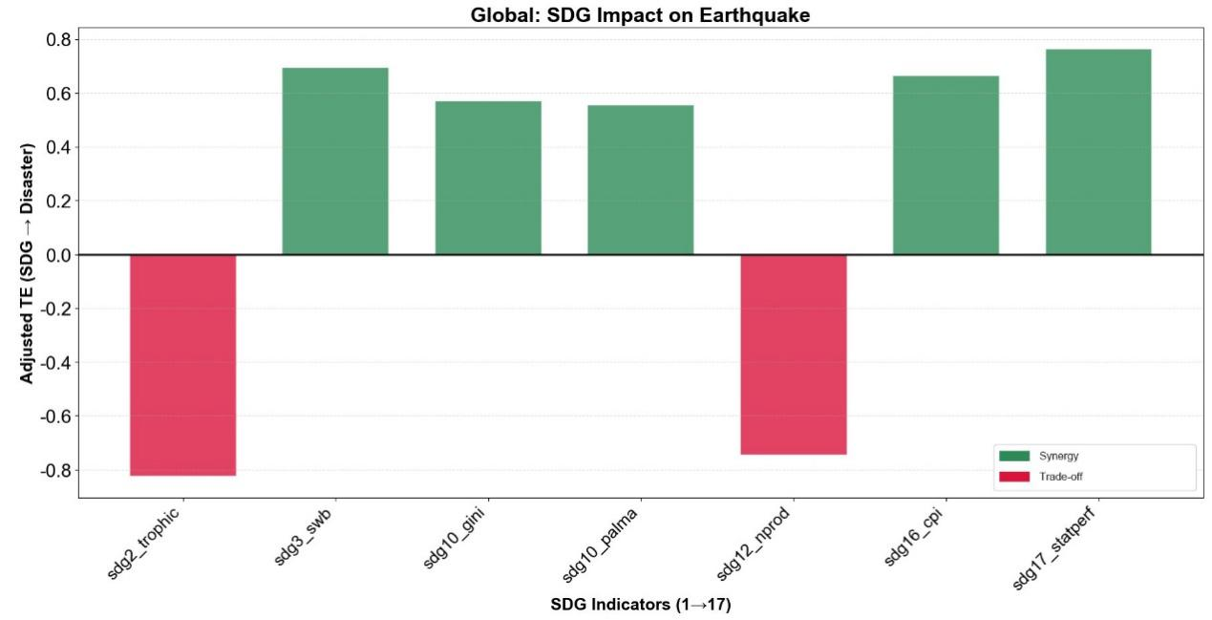
Figure 21. The impact of the SDGs on the earthquake-related affected population at the indicator level in the global system

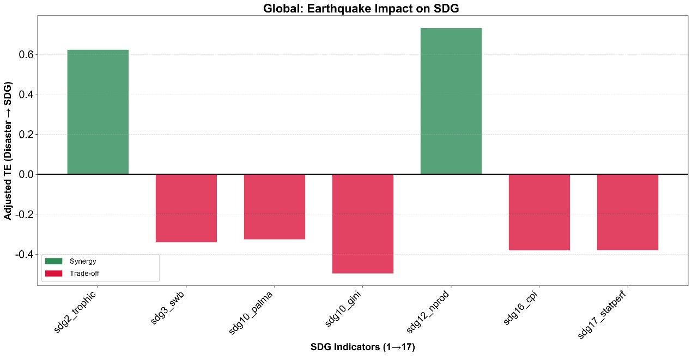
Figure 22. The impact of the earthquake-related affected population on the SDGs at the indicator level in the global system

3.2.4 The wildfire -related affected population and the SDGs
In terms of the number of people affected by global wildfires, 58 out of 60 indicators showed that the feedback effect of the implementation of SDGs in reducing the number of people affected by flood disasters (with a TE value of 0.82) was significantly greater than the impact of floods on SDGs (with a TE value of 0.44). Overall, they show a negative trade-off effect on reducing affected population, indicating that with the rapid development of the economy and society, the risk of wildfire exposure is also increasing. The indicator with the highest TE difference was sdg3_matmort (Maternal mortality ratio) and sdg16_admin (Timeliness of administrative proceedings), with TE differences of 0.76 and 0.68 respectively (Figure 23-25). This indicates that at the global scale, it is necessary to pay special attention to the trade-off between maternal health (SDG3)/administrative efficiency (SDG16) and reducing the affected population caused by wildfire.
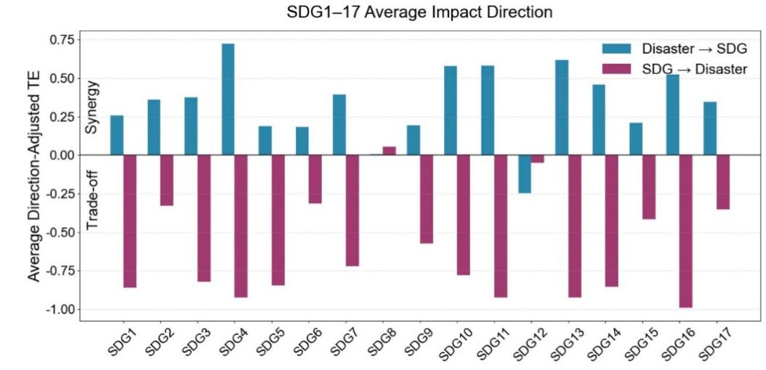
Figure 23. The bi-directional impact between the wildfire-related affected population and the SDGs at the goal level in the global system

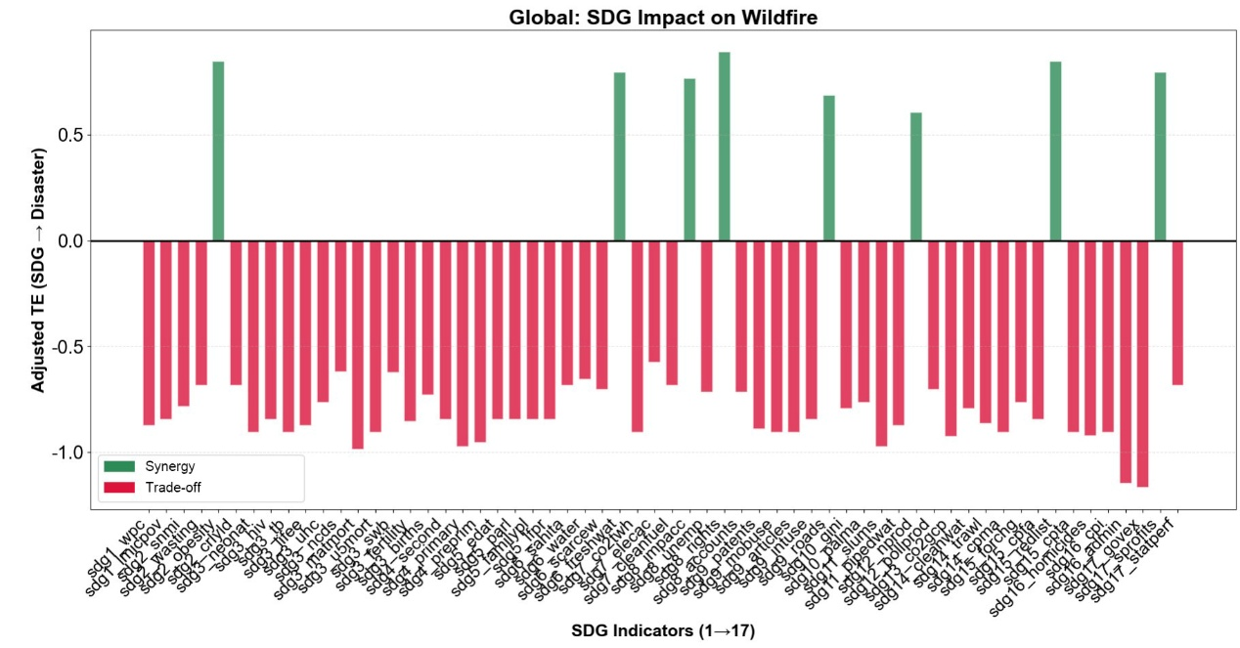
Figure 24. The impact of the SDGs on the wildfire-related affected population at the indicator level in the global system

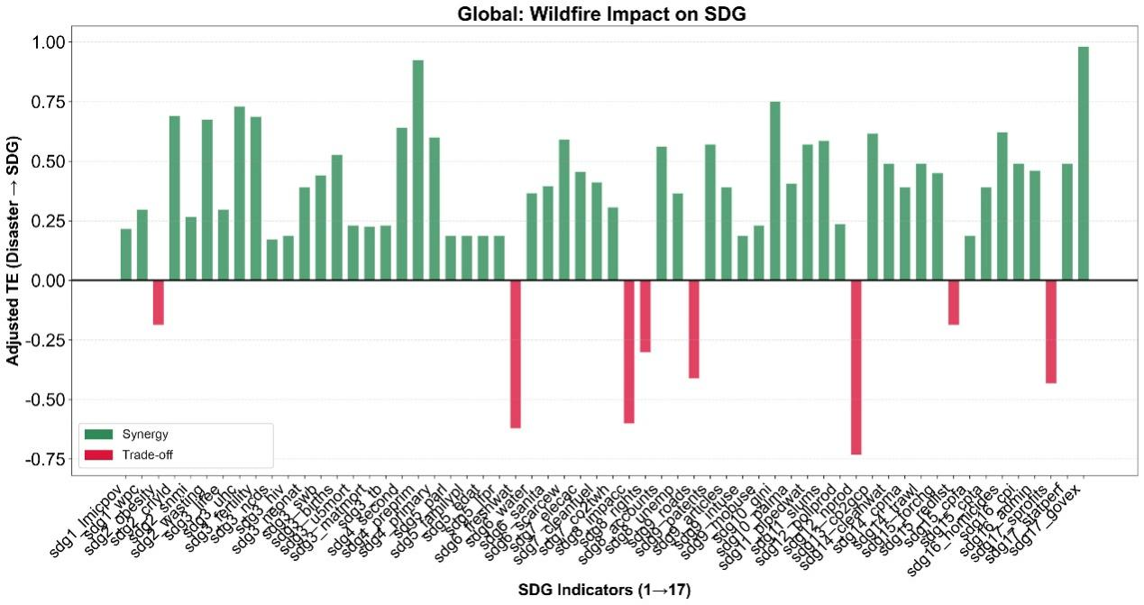
Figure 25. The impact of the wildfire-related affected population on the SDGs at the indicator level in the global system

3.3 SEM modeling of correlations between SDG indicators and disaster loss indicators

3.3.1 All disasters
To place the Asia-Pacific findings in a broader context, we further compared the transmission mechanisms identified at the global scale (Figure 26). Overall, several key patterns observed in the Asia-Pacific region were also evident worldwide. In particular, SDG 2 (Zero Hunger), SDG 11 (Sustainable Cities and Communities), and SDG 12 (Responsible Consumption and Production) remained the primary direct determinants of disaster losses.

However, notable differences emerged regarding the upstream drivers of these pathways. In the Asia-Pacific region, disaster mitigation was primarily achieved through governance capacity (SDG 16), clean water and sanitation (SDG 6), and clean energy (SDG 7). By contrast, at the global scale, ecosystem-related goals (SDG 14 and SDG 15) and international partnerships (SDG 17) played a more prominent role in initiating the transmission process. These goals indirectly reduced affected population by strengthening infrastructure, food security, clean water systems, and community resilience. Specifically, two representative global pathways were identified.

① SDG 15 / SDG 17 → SDG 9 → SDG 1 → Affected population
Life on Land (SDG 15) and Partnerships for the Goals (SDG 17) significantly promote Industry, Innovation and Infrastructure (SDG 9) (path coefficients of 0.24 and 0.23, respectively), while the improvement of infrastructure further facilitates the achievement of the poverty reduction goal (SDG 1) (0.74). The decline in poverty levels enhances residents' pre-disaster protection, risk response, and post-disaster recovery capacities, thereby significantly reducing the scale of the affected population (−0.16).

② SDG 14 / SDG 17 → SDG 6 → SDG 2 → Affected population
Life Below Water (SDG 14) and Partnerships for the Goals (SDG 17) jointly drive the improvement of Clean Water and Sanitation (SDG 6) (0.28 and 0.26), which further strengthens food security and agricultural support capacity (SDG 2) (0.74). Ultimately, SDG 2 exerts a direct negative effect on the affected population (−0.10).

These pathways highlight that, at the global scale, ecosystem protection and international cooperation function as foundational drivers by strengthening basic resource security and infrastructure-related capacities, which in turn enhances community resilience to disasters.

Compared with the affected-population model, the mechanisms underlying economic losses exhibited a higher degree of consistency between the Asia-Pacific and global scales. Both models revealed an asset-exposure effect associated with urban development and a mitigation effect arising from responsible consumption and production. These findings suggest that regional differences are more pronounced in pathways influencing human impacts, whereas the mechanisms shaping economic losses appear to be relatively universal across scales.
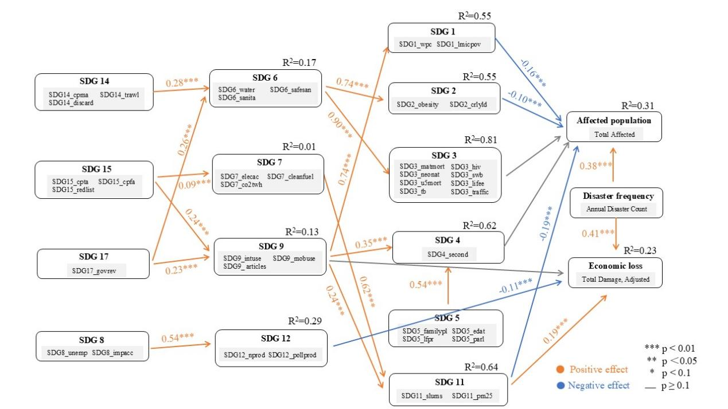
Figure 26. SEM results for all disaster loss based on SDG indicators selected at the 90% confidence level (p < 0.1) at the global scale

3.3.2 Earthquake
Regarding the affected population, neither social development indicators (e.g., SDG 3) nor production transformation indicators (e.g., SDG 12) exhibited statistically significant direct disaster-mitigation effects on earthquake-related affected populations on the global scale (Figure 27).

In the global model, Peace, Justice and Strong Institutions (SDG 16) showed a significant positive effect on Good Health and Well-being (SDG 3) (0.50). In the Asia-Pacific model, Gender Equality (SDG 5) also significantly promoted SDG 3 (0.43). Crucially, however, the subsequent impact of SDG 3 on the affected population failed to achieve statistical significance across both spatial scales. This suggests that improvements in routine social health and medical conditions are difficult to translate into immediate reductions in casualties in earthquakes.

In addition, although the global model identified a transmission pathway from Reduced Inequalities (SDG 10) to Zero Hunger (SDG 2), the effect of SDG 2 on the affected population was also not statistically significant, consistent with the results observed in the Asia-Pacific region.
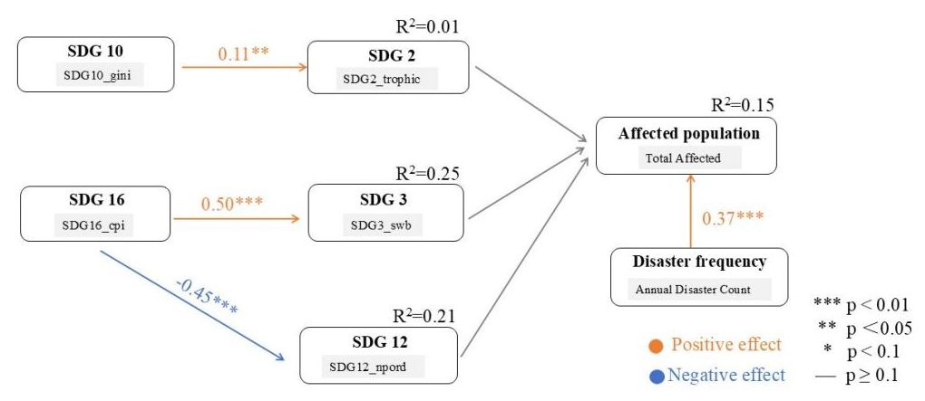
Figure 27. SEM results for earthquake loss based on SDG indicators selected at the 90% confidence level (p < 0.1) at the global scale

3.3.3 Flood
Regarding the affected population, at the global scale, SDG 2 (Zero Hunger) and SDG 11 (Sustainable Cities and Communities) both exhibited significant negative effects on the affected population, while Quality Education (SDG 4) showed a positive direct effect (0.12) (Figure 28).

Institutional governance capacity (SDG 16) demonstrated a strong driving effect on Clean Water and Sanitation (SDG 6), with a path coefficient of 0.60, which is substantially higher than that in the Asia-Pacific regional model (0.12). This indicates that, at the global scale, national governance capacity and institutional effectiveness serve as fundamental drivers for the development of water security infrastructure.

Compared with the Asia-Pacific regional model, SDG 17 (Partnerships for the Goals) exhibits a stronger regulatory effect at the global scale.

① SDG 17 → SDG 8 → SDG 12 → Economic loss
SDG 17 showed a significant negative effect on economic growth (SDG 8) (-0.35). This suggests that, at the global level, mechanisms such as international cooperation, development assistance, and green agreements impose certain constraints on traditional high-growth, resource-intensive development models.

② SDG 17 → SDG 9 → SDG 11 → Affected population / Economic loss
In the global model, SDG 17 exerted a significant positive effect on Industry and Infrastructure (SDG 9) (0.13), indicating that cross-border cooperation leads to targeted flows of capital and technology into industrial and infrastructure sectors.

SDG 9 further promoted urbanization processes (SDG 11) (0.21), thereby influencing both population exposure and economic loss. This suggests that global partnership networks (SDG 17), through a multi-level mediation pathway, indirectly reshape the patterns of flood-related population reduction (-0.18) and asset exposure (0.08) in urban systems worldwide.
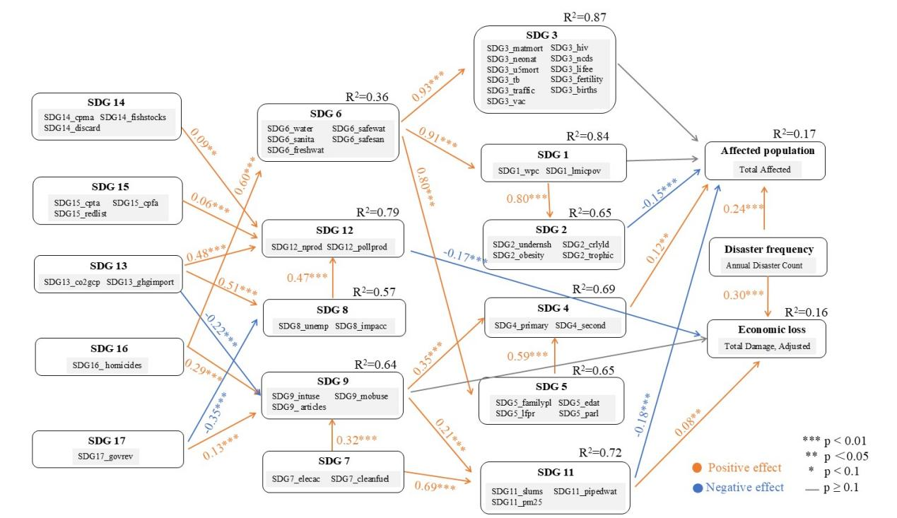
Figure 28. SEM results for flood loss based on SDG indicators selected at the 90% confidence level (p < 0.1) at the global scale

3.3.4 Drought
Compared with the Asia-Pacific drought model, the global drought model formed a relatively clearer explanatory pathway for economic loss. The direct positive effect of SDG 2 (Zero Hunger) on economic loss was significant (0.17), suggesting that food- and nutrition-related development levels may be associated with higher economic exposure. The direct positive effect of SDG 4 (Quality Education) on economic loss was also significant (0.18), indicating that regions with higher levels of educational development may have greater concentrations of assets and economic activities, which can amplify economic loss after disasters occur. By contrast, the direct negative effect of SDG 12 (Responsible Consumption and Production) on economic loss was significant (-0.21), suggesting that more responsible consumption and production patterns may help reduce disaster-related economic loss.

Some SDGs also indirectly affected economic loss through mediating pathways. SDG 6 (Clean Water and Sanitation) influenced economic loss through the pathway of SDG 6 → SDG 2 → Economic loss, indicating that water and sanitation conditions may further shape disaster loss through the food system. SDG 5 (Gender Equality) influenced economic loss through the pathway of SDG 5 → SDG 4 → Economic loss, suggesting that gender equality may affect economic vulnerability through educational development. SDG 9 (Industry, Innovation and Infrastructure) and SDG 13 (Climate Action) mainly operated through SDG 12 (Responsible Consumption and Production), indicating that infrastructure, industrial innovation, and climate action influenced economic loss through production and consumption structures.

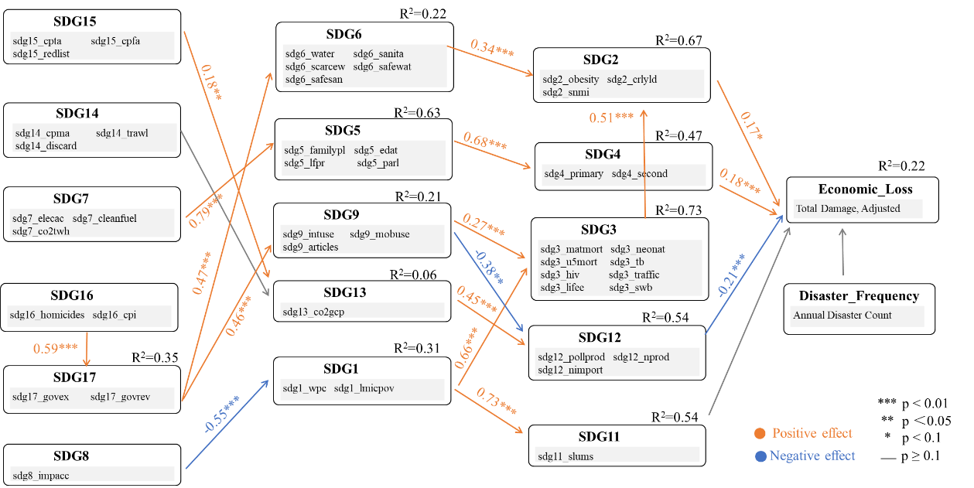
Figure 29. SEM results for drought loss based on SDG indicators selected at the 90% confidence level (p < 0.1)

4. Results for the Asia-Pacific Region
The Asia-Pacific region accounts for a substantial proportion of global disaster losses and remains one of the world's most disaster-prone regions, while simultaneously experiencing rapid economic and social development [10]. These characteristics make the region an important case for exploring the interactions between disaster losses and SDG progress. Regional analysis in the Asia-Pacific can further reveal context-specific pathways and provide a useful complement to the global-scale assessment.

4.1 The interaction between economic loss and the SDGs
This section examines the relationship between economic loss from disasters and the SDGs implementations in the Asia-Pacific region. The analysis covers the total average economic losses from disasters in the Asia-Pacific region, and the hazard-specific economic losses from floods, storms and earthquakes.

4.1.1 Total average economic loss and the SDGs
Overall, the feedback effect of the SDG progress on total average disaster economic losses in the Asia-Pacific region (transfer entropy value 0.92) is significantly higher than the impact of disaster economic losses on SDG progress (0.42). This is observed for 43 out of the 46 SDG indicators with detected causal relationships. Among them, the indicators with the greatest differences for transfer entropy are sdg3_neonat (Neonatal mortality rate), sdg3_u5mort (Mortality rate, under-5), sdg9_intuse (Population using the internet), sdg14_cpma (Mean area that is protected in marine sites important to biodiversity), sdg15_cpta (Mean area that is protected in terrestrial sites important to biodiversity), sdg15_cpfa (Mean area that is protected in freshwater sites important to biodiversity), and sdg15_redlist (Red List Index of species survival), with a difference of 0.7 for all (Figure 30-32). It means that although the implementation of the SDGs in the Asia-Pacific region has generally brought rapid socio-economic development, it also led to high disaster exposure, resulting in increased disaster-related economic losses. Particular attention is needed to address the trade-offs between protecting terrestrial and marine biodiversity/expanding internet access/ reducing child mortality and minimizing overall disaster economic losses.
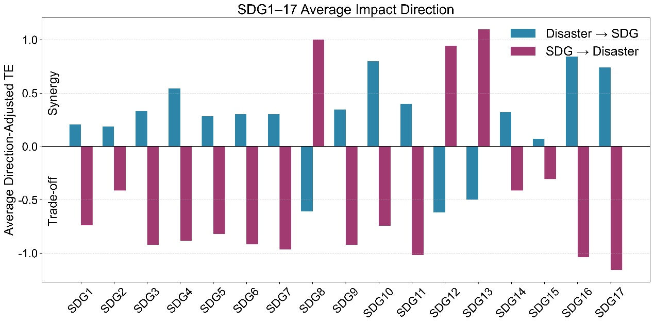
Figure 30. The bi-directional impact between the total average economic loss and the SDGs at the goal level in the Asia-Pacific region

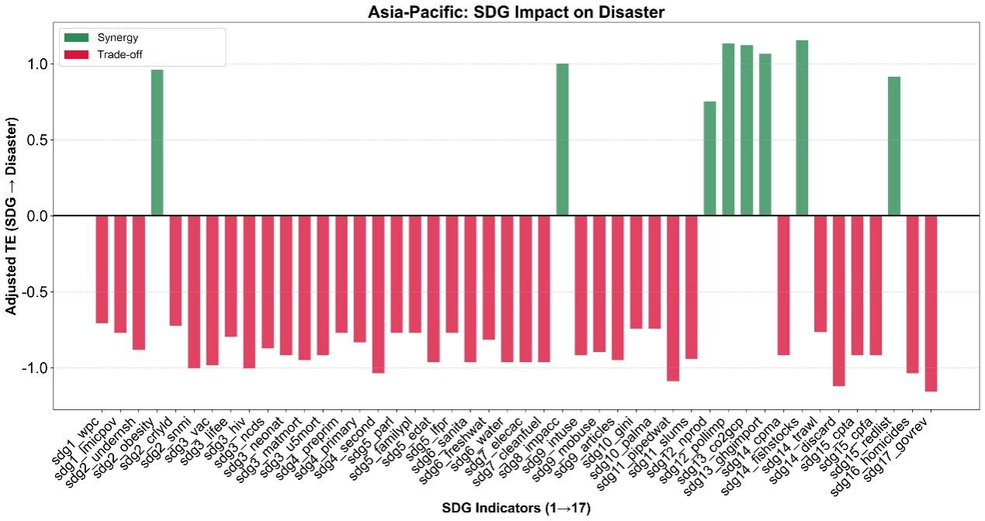
Figure 31. The impact of the SDGs on the total average economic loss at the indicator level in the Asia-Pacific region
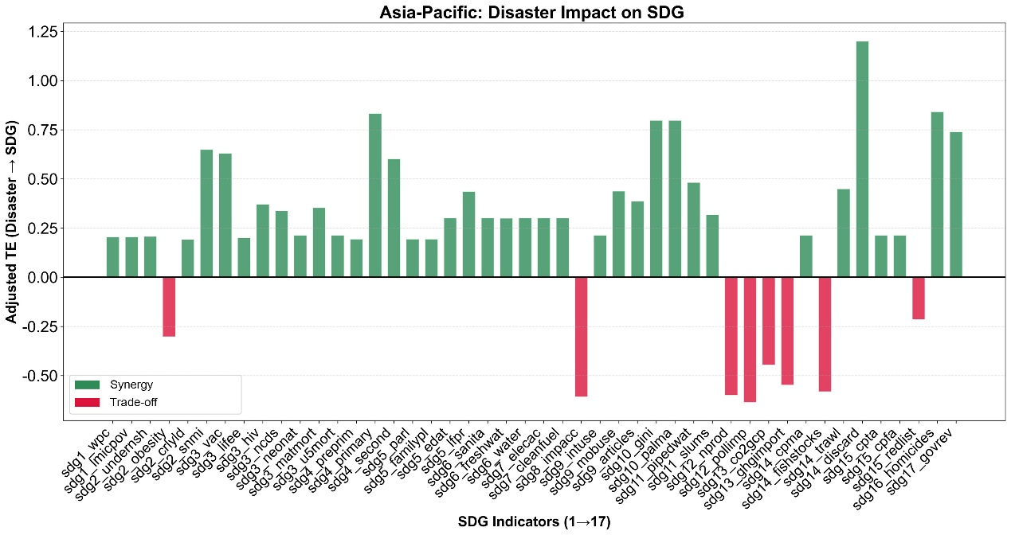
Figure 32. The impact of the total average economic loss on the SDGs at the indicator level in the Asia-Pacific region

4.1.2 The flood-related economic loss and the SDGs
Regarding the flood-related economic losses in the Asia-Pacific region, the feedback effect of SDG progress on the flood-related economic losses has a transfer entropy value of 0.70, which is higher than the impact of economic losses from floods on SDG progress, with a transmission entropy value of 0.42. This is observed in 37 out of the 42 SDG indicators with detected causal relationships. Among them, the indicators with the greatest differences are sdg3_traffic (Traffic deaths) and sdg3_hiv (New HIV infection), with the transfer entropy differences of 0.59 and 0.51, respectively (Figure 33-35). This means that while the implementation of SDGs in the Asia-Pacific region has brought rapid socio-economic development, it has also led to higher exposure to floods, resulting in increased economic losses from flooding. Particular attention is needed to address the trade-offs between reducing road traffic fatalities/HIV prevention and minimizing flood-related economic damages.
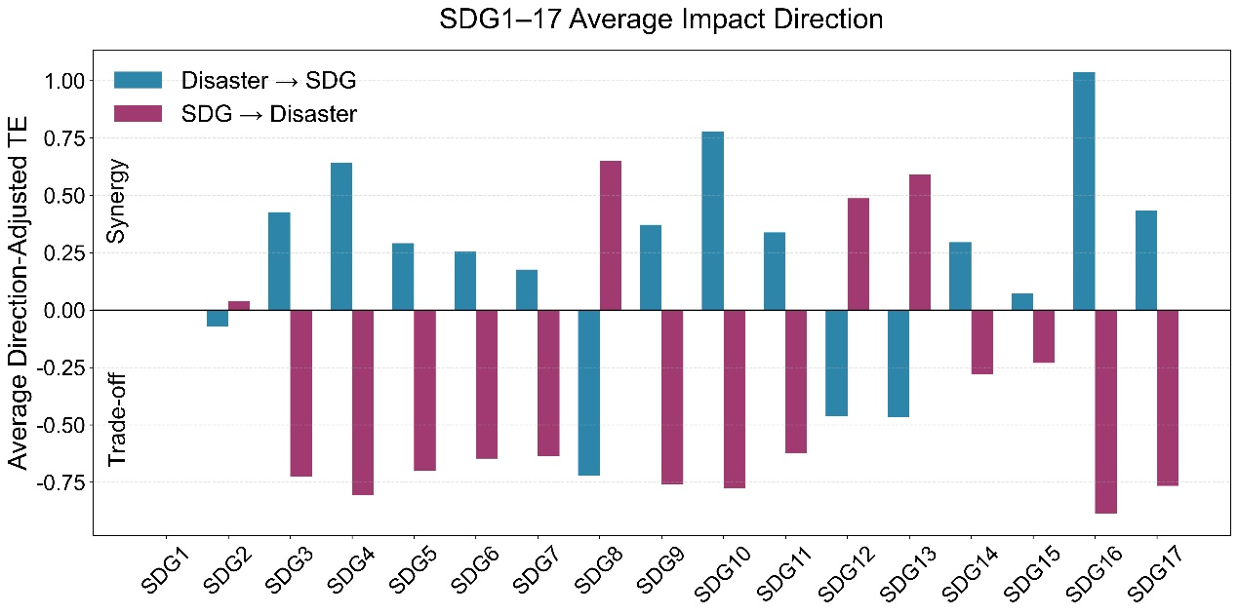
Figure 33. The bi-directional impact between the flood-related economic loss and the SDGs at the goal level in the Asia-Pacific region

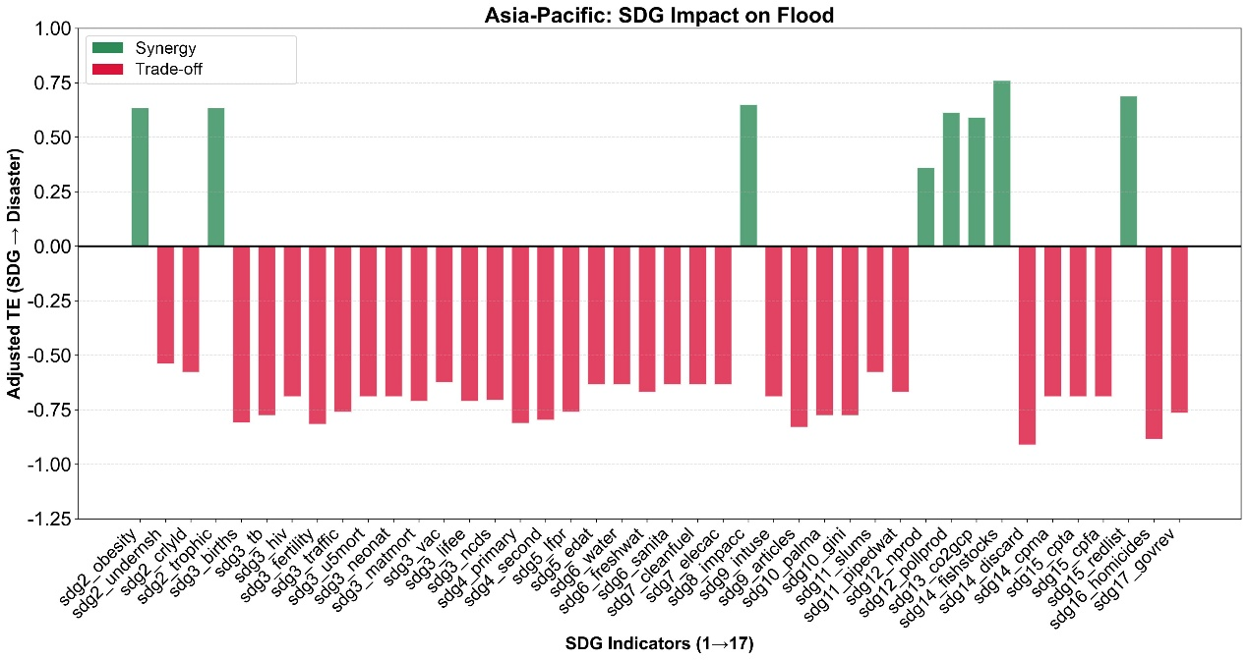
Figure 34. The impact of the SDGs on the flood-related economic loss at the indicator level in the Asia-Pacific region
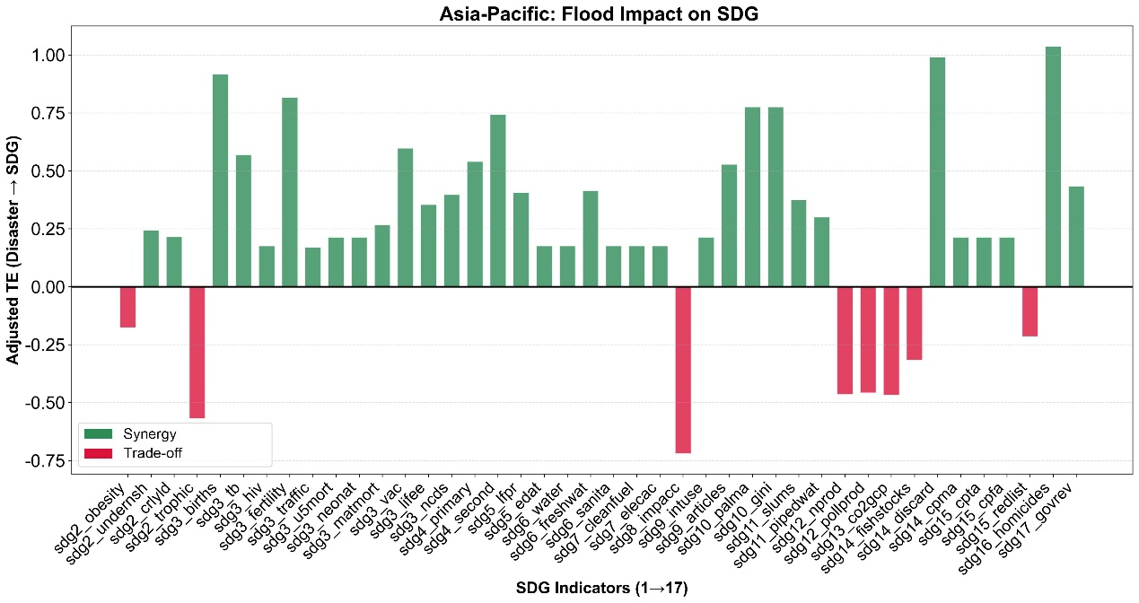
Figure 35. The impact of the flood-related economic loss on the SDGs at the indicator level in the Asia-Pacific region

4.1.3 The storm-related economic loss and the SDGs
For the storm-related economic losses in the Asia-Pacific region, the feedback effect of SDG progress on these losses, with a transfer entropy value of 1.04, is significantly higher than the impact of storm-related economic losses on SDG progress, which has a transfer entropy value of 0.38. This is observed in 20 out of the 21 SDG indicators with detected causal relationships. Among them, the indicators with the greatest differences are sdg3_lifee and sdg3_ncds, both with transfer entropy differences of 0.92 (Figure 36-38). This means that the implementation of SDGs in the Asia-Pacific region has promoted rapid economic and social development, but at the same time, it has led to high exposure to storm surge, resulting in an increase in economic losses caused by storm surges. In particular, it is necessary to reverse the trade-off between improving the life expectancy of the people/reducing the occurrence of diseases and reducing the economic losses caused by storm surges.
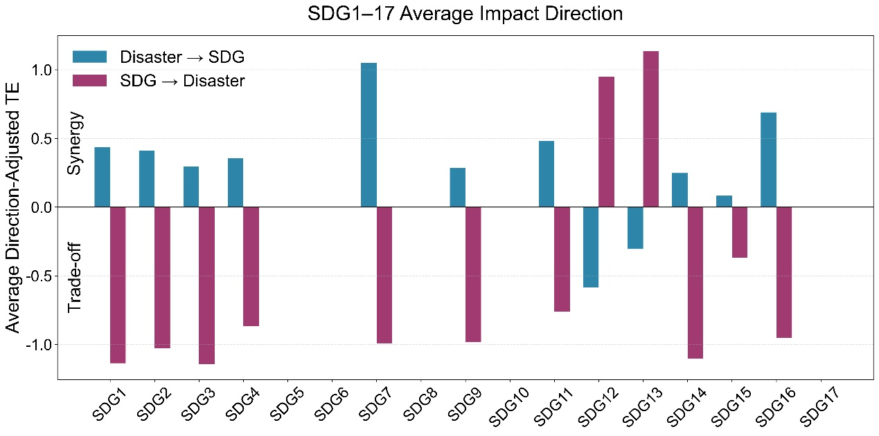
Figure 36. The bi-directional impact between the storm-related economic loss and the SDGs at the goal level in the Asia-Pacific region

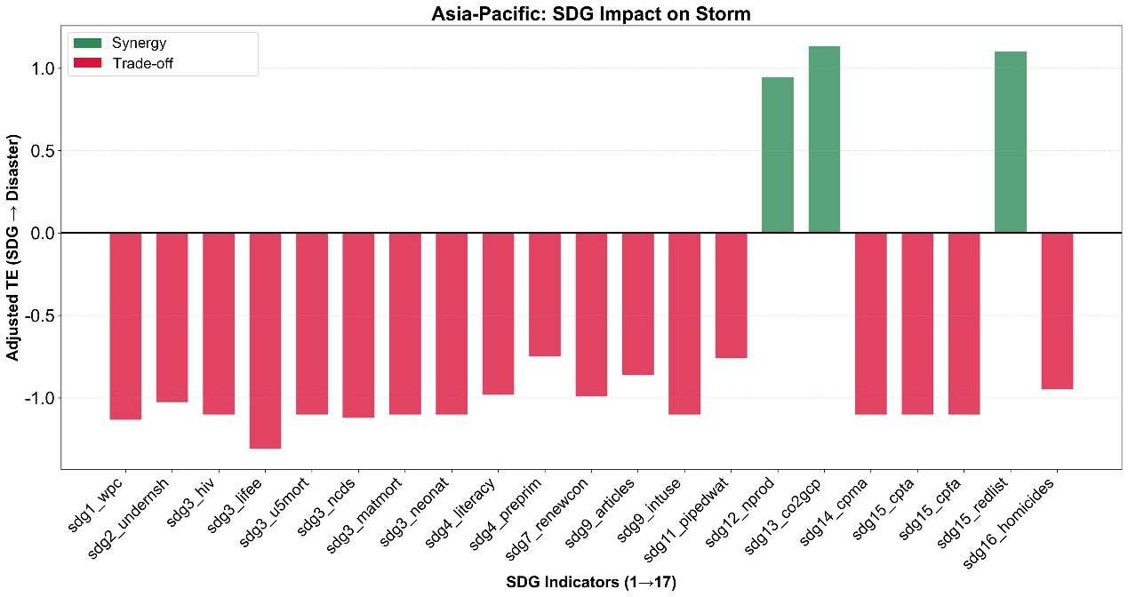
Figure 37. The impact of the SDGs on the storm-related economic loss at the indicator level in the Asia-Pacific region
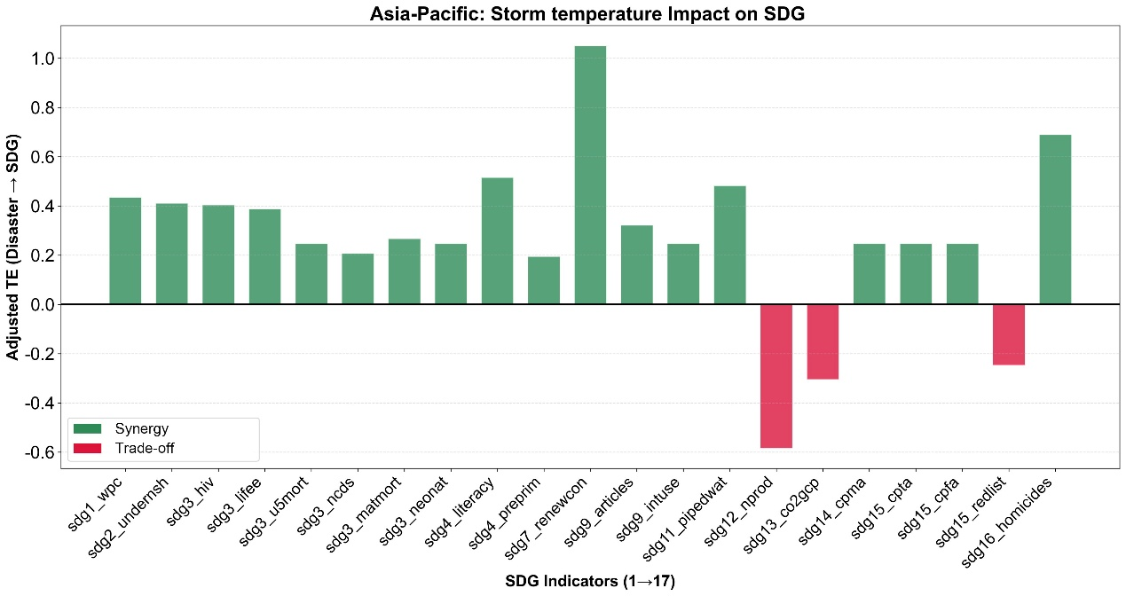
Figure 38. The impact of the storm-related economic loss on the SDGs at the indicator level in the Asia-Pacific region

4.1.4 The earthquake-related economic loss and the SDGs
With respect to the earthquake-related economic losses in the Asia-Pacific region, the feedback effect of SDG progress on economic losses from earthquakes has a transfer entropy value of 0.93, which is higher than the impact of economic losses from earthquakes on SDG progress, with a transfer entropy value of 0.77. This is evident for all four SDG indicators with detected causal relationships. Among them, the indicator with the greatest difference is sdg2_trophic, with the transfer entropy differences of 0.31 (Figure 39-41). It means that the implementation of SDGs in the Asia-Pacific region has promoted rapid economic and social development, but in the meantime, it has led to high exposure to earthquake disasters and an increase in earthquake-related economic losses. In particular, it is necessary to reverse the trade-off between improving people's nutritional levels and reducing earthquake-related economic losses.
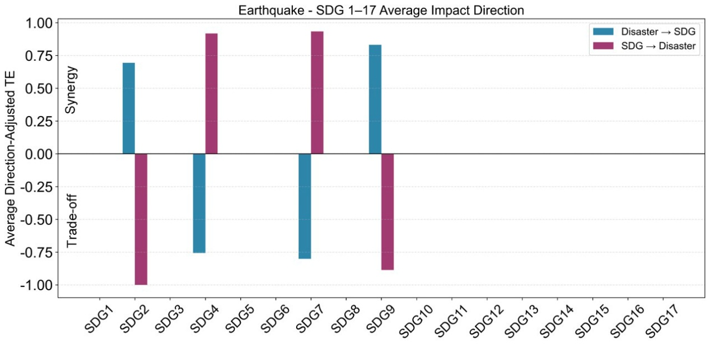
Figure 39. The bi-directional impact between the earthquake-related economic loss and the SDGs at the goal level in the Asia-Pacific region

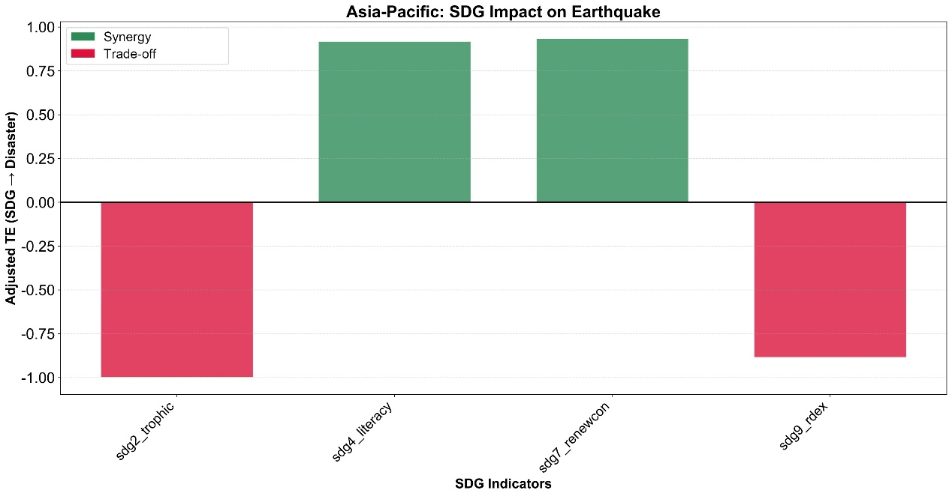
Figure 40. The impact of the SDGs on the earthquake-related economic loss at the indicator level in the Asia-Pacific region
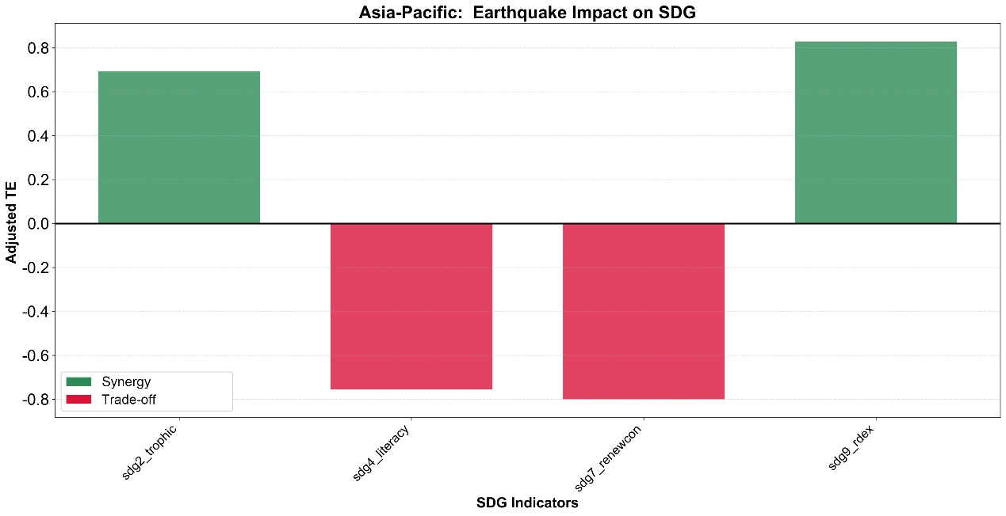
Figure 41. The impact of the earthquake-related economic loss on the SDGs at the indicator level in the Asia-Pacific region

4.2 The interaction between affected population and the SDGs
This section exams the relationship between disaster-related affected population and the SDGs implementations in the Asia-Pacific region. The analysis covers the total average disaster-related affected population, as well as the hazard-specific affected population from floods, extreme temperatures, and earthquakes.

4.2.1 The total average affected population and the SDGs
Overall, the transfer entropy of the feedback effect of SDG progress on total average affected population in the Asia-Pacific region is 0.88, significantly higher than the impact of affected population on SDG progress, which is 0.40. This is true for all 41 SDG indicators with detected causal relationships. Among them, the indicators with the greatest differences are sdg4_preprim (Participation rate in pre-primary organized learning), sdg1_wpc (Poverty headcount ratio at $2.15/day), and sdg3_lifee (Life expectancy at birth), with the transfer entropy differences of 0.83, 0.74, and 0.74, respectively (Figure 42-44). This means that the integrated implementation of the SDGs in the Asia-Pacific region is conducive to reducing total disaster-related affected population, especially by increasing the preschool education coverage rate, reducing the proportion of people living in extreme poverty, and increasing life expectancy, which can significantly reduce total disaster-related affected population.
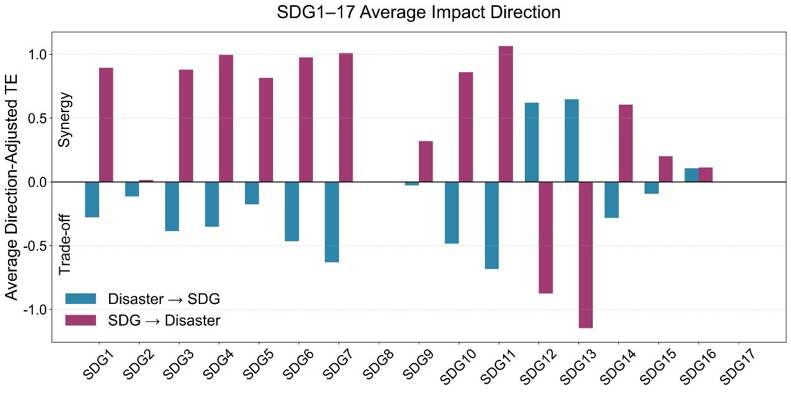
Figure 42. The bi-directional impact between the total average affected population and the SDGs at the goal level in the Asia-Pacific region

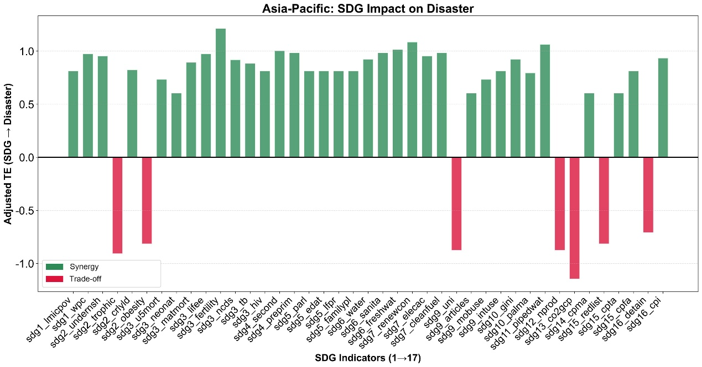
Figure 43. The impact of the SDGs on the total average affected population at the indicator level in the Asia-Pacific region

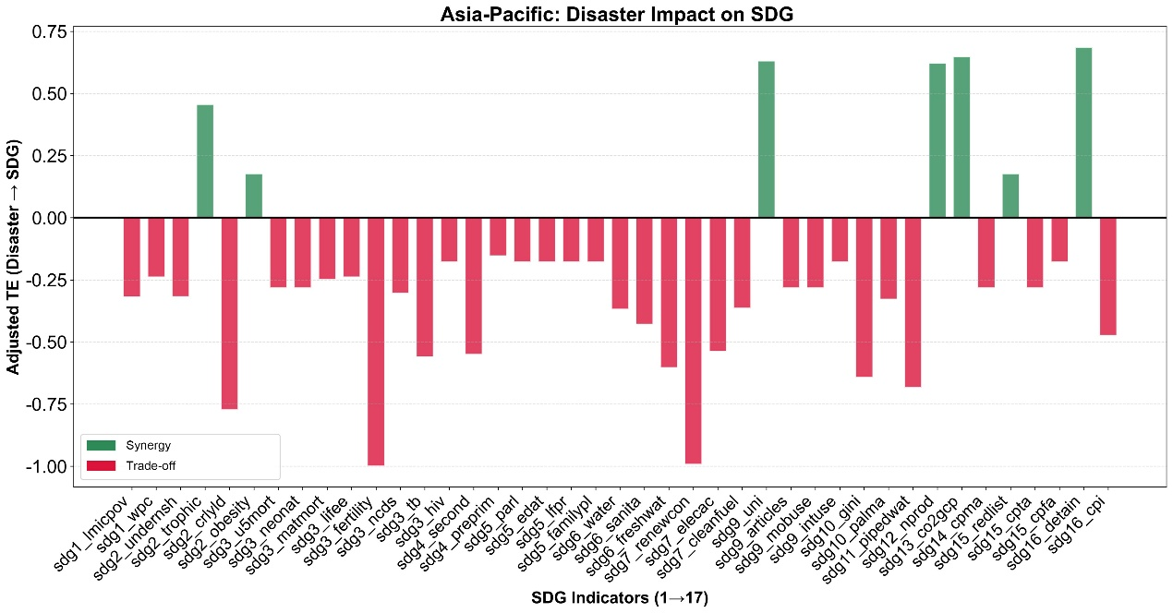
Figure 44. The impact of the total average affected population on the SDGs at the indicator level in the Asia-Pacific region

4.2.2 The flood-related affected population and the SDGs
Regarding the flood-related affected population in the Asia-Pacific region, the transfer entropy of the feedback effect of SDG progress on affected population is 0.87, significantly higher than the impact of affected population from floods on SDG progress, which is 0.39. This pattern is observed in 39 out of the 40 SDG indicators with detected causal relationships. Among them, the indicators with the greatest differences are sdg3_ncds (Age-standardized death rate due to cardiovascular disease, cancer, diabetes, or chronic respiratory disease in adults aged 30 to 70 years) and sdg11_slums (Proportion of urban population living in slums), with the transfer entropy differences reaching 0.81 and 0.77, respectively (Figure 45-47). This means that the integrated implementation of the SDGs in the Asia-Pacific region is beneficial in reducing the flood-related affected population, especially by significantly reducing disease mortality and urban poverty.
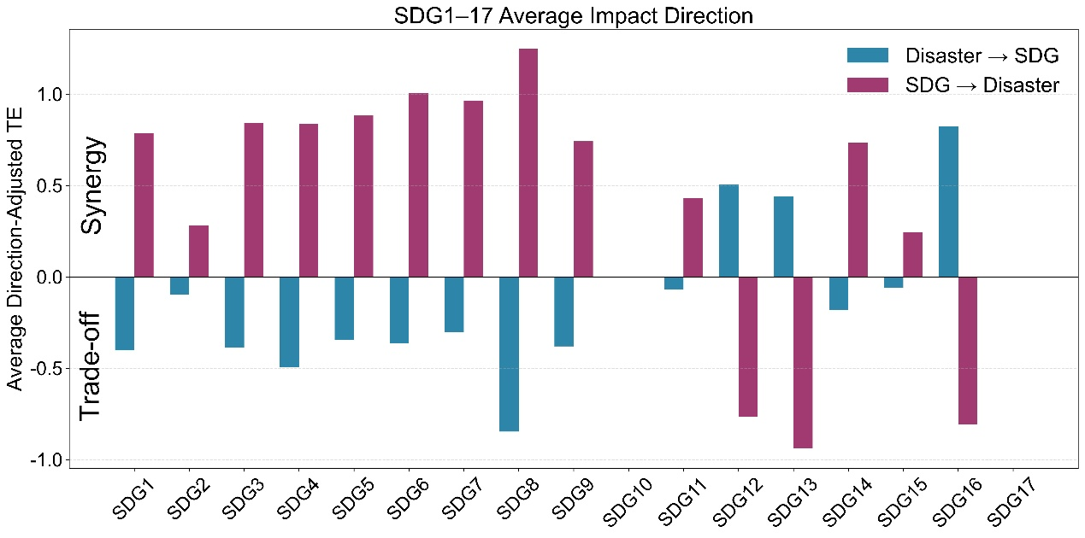
Figure 45. The bi-directional impact between the flood-related affected population and the SDGs at the goal level in the Asia-Pacific region

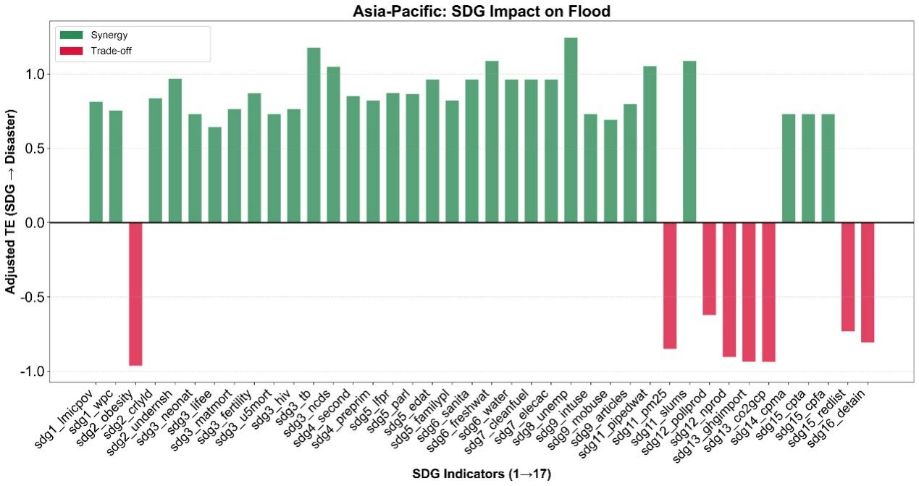
Figure 46. The impact of the SDGs on the flood-related affected population at the indicator level in the Asia-Pacific region
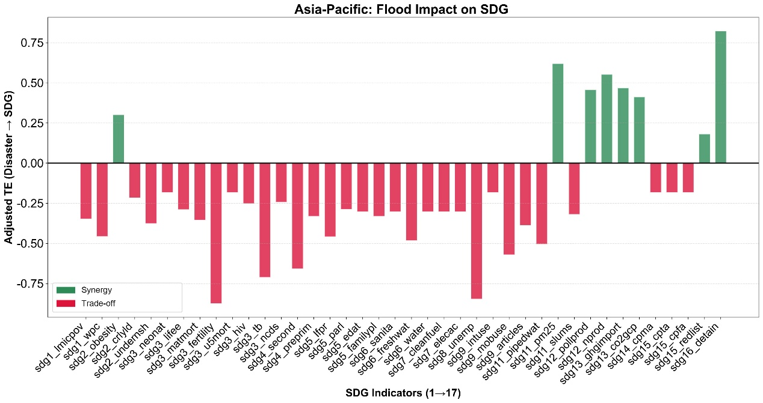
Figure 47. The impact of the flood-related affected population on the SDGs at the indicator level in the Asia-Pacific region

4.2.3 The extreme temperature-related affected population and the SDGs
With respect to the extreme temperature-related affected population in the Asia-Pacific region, the transfer entropy of the feedback effect of SDG progress on affected population is 0.87, which is significantly higher than the impact of extreme temperature-related affected population on the SDG progress, with a transfer entropy of 0.46. This is observed in 30 out of the 31 SDG indicators with detected causal relationships. Among them, the indicators with the greatest differences are sdg6_freshwat (Freshwater withdrawal), sdg5_lfpr (Ratio of female-to-male labor force participation rate), sdg5_familypl (Demand for family planning satisfied by modern methods), sdg1_wpc (Poverty headcount ratio at $2.15/day), and sdg1_lmicpov (Poverty headcount ratio at $3.65/day), with the transfer entropy differences of 0.78, 0.69, 0.69, 0.69, and 0.69, respectively (Figure 48-50). This means that while the implementation of the SDGs in the Asia-Pacific region has brought about rapid economic development, it has also led to increased affected population due to extreme temperature disasters. It is necessary to pay more attention to the interaction between the extreme temperature and the aspects of freshwater resource utilization, gender equality, and poverty reduction.
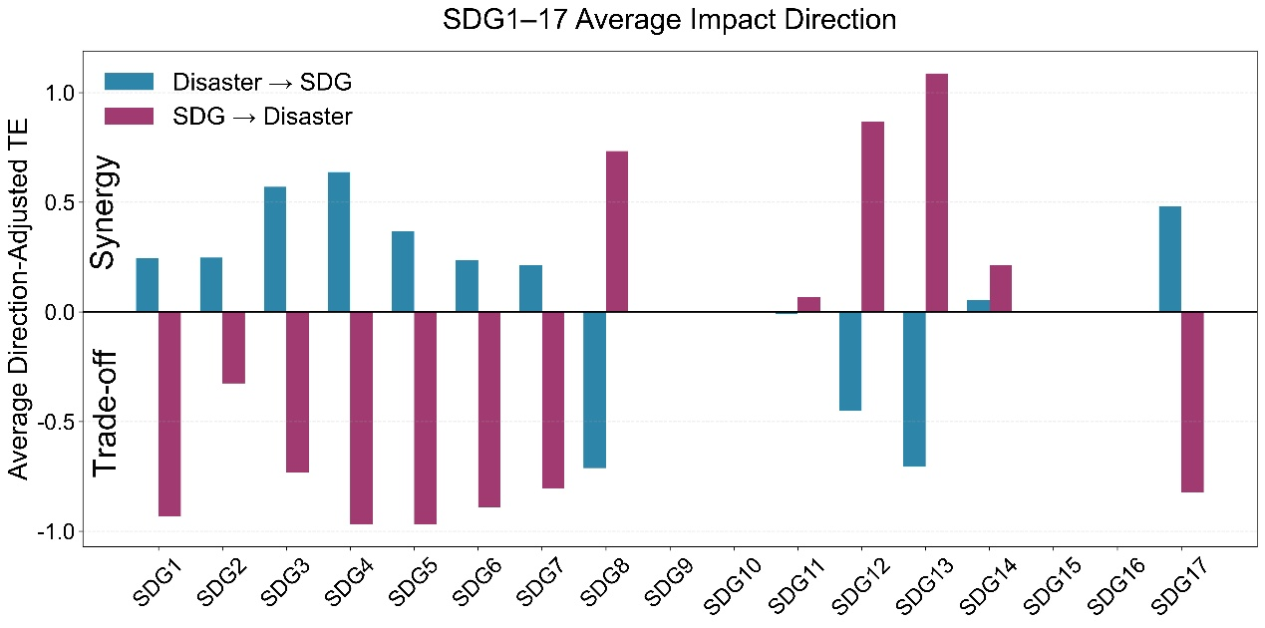
Figure 48. The bi-directional impact between the extreme temperature-related affected population and the SDGs at the goal level in the Asia-Pacific region

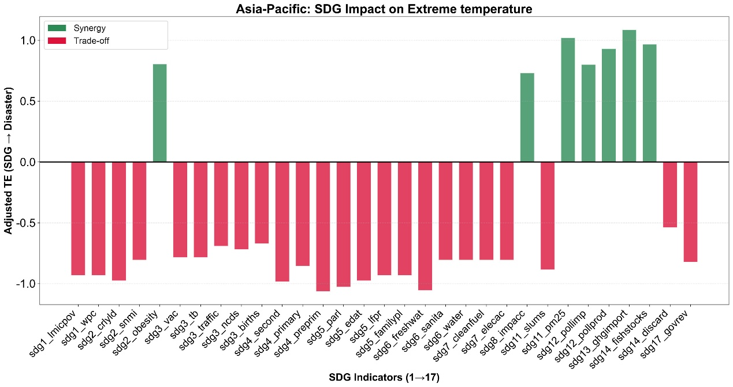
Figure 49. The impact of the SDGs on the extreme temperature-related affected population at the indicator level in the Asia-Pacific region

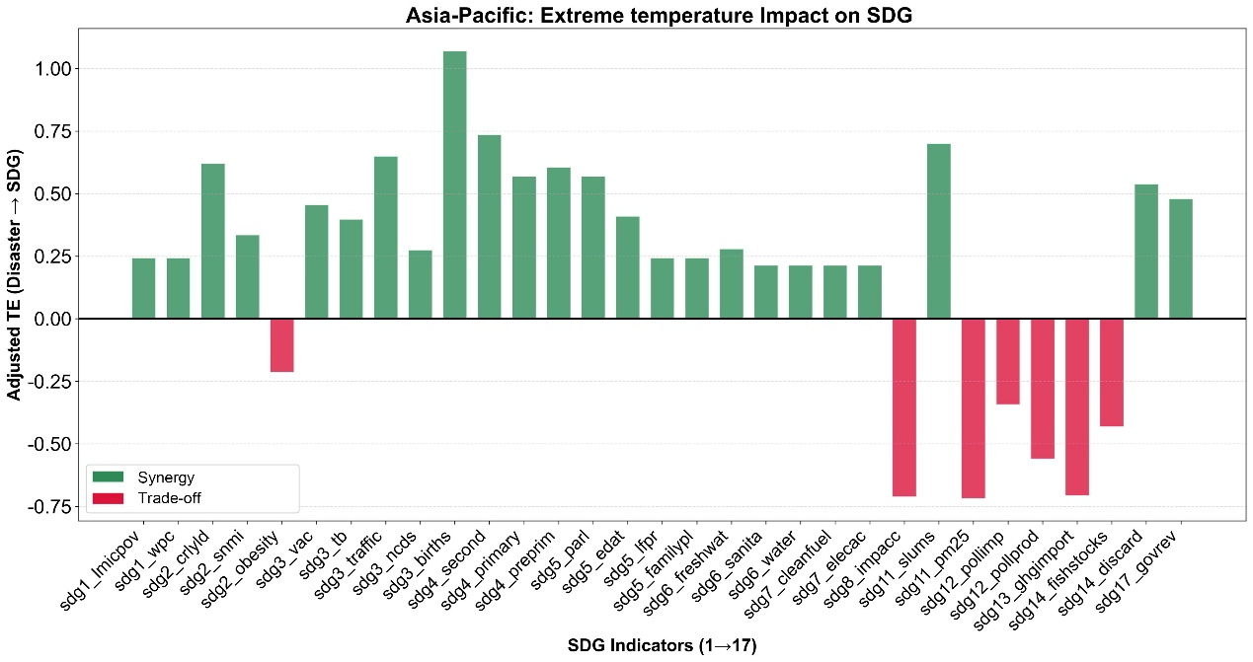
Figure 50. The impact of the extreme temperature-related affected population on the SDGs at the indicator level in the Asia-Pacific region

4.2.4 The earthquake-related affected population and the SDGs
For the earthquake-related affected population in the Asia-Pacific region, the transfer entropy value of the feedback effect of the SDG progress on affected population is 0.89, which is higher than the impact of affected population due to earthquakes on SDG progress, with a value of 0.66. This is observed in 6 out of the 7 SDG indicators with detected causal relationships. Among them, the indicator with the greatest difference is sdg5_lfpr (Ratio of female-to-male labor force participation rate) with a transfer entropy difference of 0.43 (Figure 51-53). This means that the implementation of the SDGs in the Asia-Pacific region is beneficial to reducing the affected population from earthquake, mainly through reducing gender inequality.
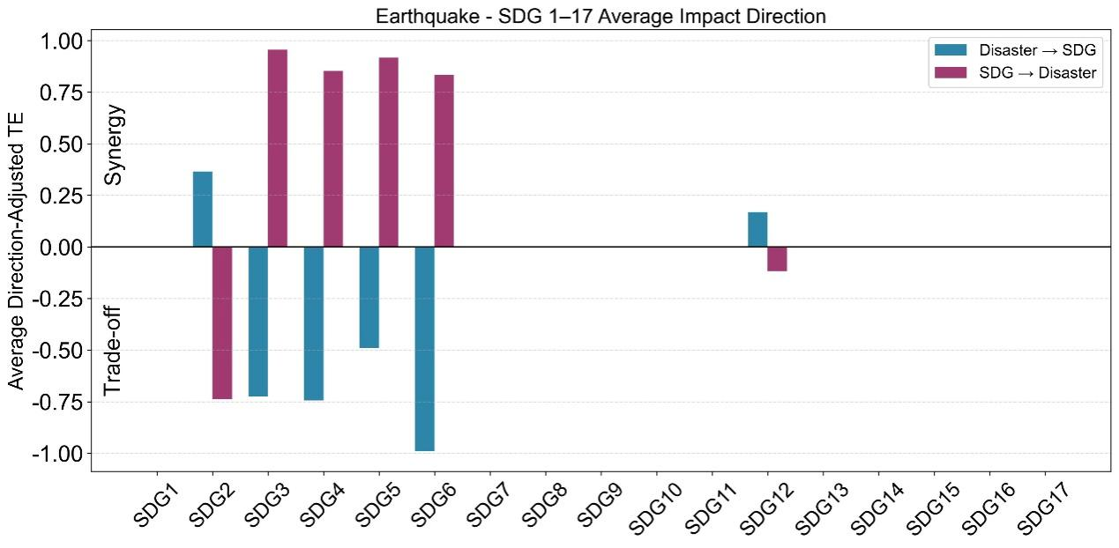
Figure 51. The bi-directional impact between the affected population of the earthquake and the SDGs at the goal level in the Asia-Pacific region

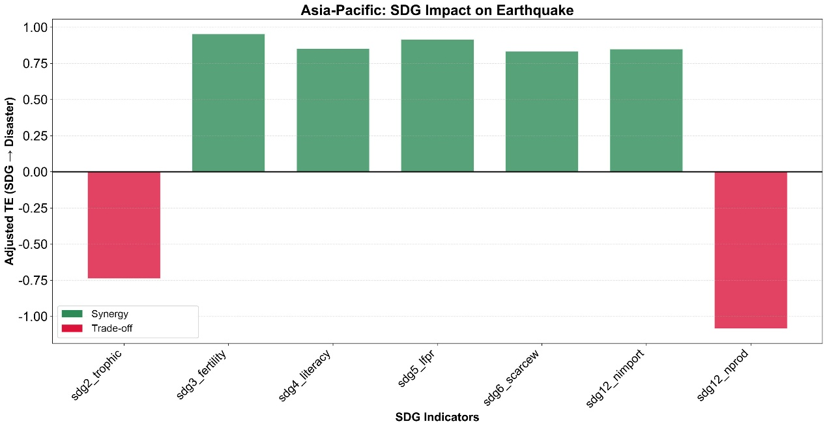
Figure 52. The impact of the SDGs on the affected population of the earthquake at the indicator level in the Asia-Pacific region
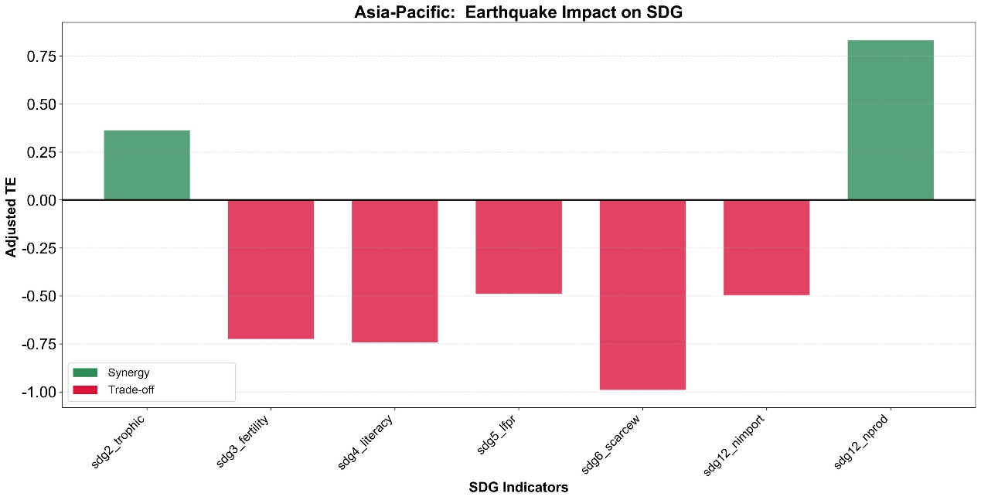
Figure 53. The impact of the affected population of the earthquake on the SDGs at the indicator level in the Asia-Pacific region

4.3 SEM modeling of correlations between SDG indicators and disaster loss indicators
This study developed SEMs linking SDG indicators with disaster loss across multiple hazard types, including all disasters, earthquakes, floods, droughts, mass movement, and extreme temperatures. The objective was to examine the heterogeneous effects of sustainable development under different hazard shocks, as well as the corresponding transmission mechanisms. For indicator screening, only those exhibiting a correlation coefficient (r >0.5) with affected populations and economic loss and reaching statistical significance (at the 90% or 95% confidence levels) were selected to construct the respective SEMs.

4.3.1 All disasters
In terms of affected population, SDG 2 (Zero Hunger) and SDG 11 (Sustainable Cities and Communities) exerted significant direct negative effects (Figure 54). While other indicators did not directly reduce affected population, they played indirect roles through these two core variables, revealing two distinct transmission paths.

① SDG 16 → SDG 6 → (SDG 3 → SDG 1 →) SDG 2 → Affected population
Strong governance and institutions (SDG 16) promoted the universalization of clean water and sanitation (SDG 6, path coefficient: 0.49), which laid the foundation for good health and well-being (SDG 3, 0.87). Secure health outcomes effectively prevented poverty (SDG 1, 0.75), thereby strengthening regional food and agricultural security (SDG 2, 0.17). Ultimately, SDG 2 exhibited the most substantial direct mitigation effect (-0.27). This suggested that during disasters, securing the fundamental livelihood served as a critical social buffer for reducing casualties.

② SDG 7 → (SDG 9 →) SDG 11 → Affected population
Clean energy (SDG 7) not only directly enhanced the sustainability of cities and communities (SDG 11, 0.53) but also indirectly empowered SDG 11 by supporting resilient infrastructure (SDG 9). Consequently, highly resilient and sustainable communities (SDG 11) directly reduced the scope of population impact during disasters (-0.12).

In terms of economic loss, core variables directly influencing loss were SDG 12 (Responsible Consumption and Production) and SDG 11 (Sustainable Cities and Communities). These demonstrated two transmission paths with contrasting directions (Figure 54).

③ SDG 13 → (SDG 8 →) SDG 12 → Economic loss
Proactive climate action (SDG 13) significantly promoted economic growth (SDG 8, 0.71) and drove responsible industrial consumption and production patterns (SDG 12). SDG 12 eventually exerted a significant negative effect on economic loss (-0.13). This indicated that high-quality, sustainable industrial models guided by climate action effectively mitigated direct economic loss.

④ SDG 7 → (SDG 9 →) SDG 11 → Economic loss
In contrast to the findings for affected population, sustainable cities (SDG 11) with highly developed energy (SDG 7) and infrastructure (SDG 9) systems exhibited higher absolute economic loss (0.17). As developed cities possessed higher asset density and supply chain value, their absolute economic loss was inevitably greater when struck by disasters, despite better protection for human lives.

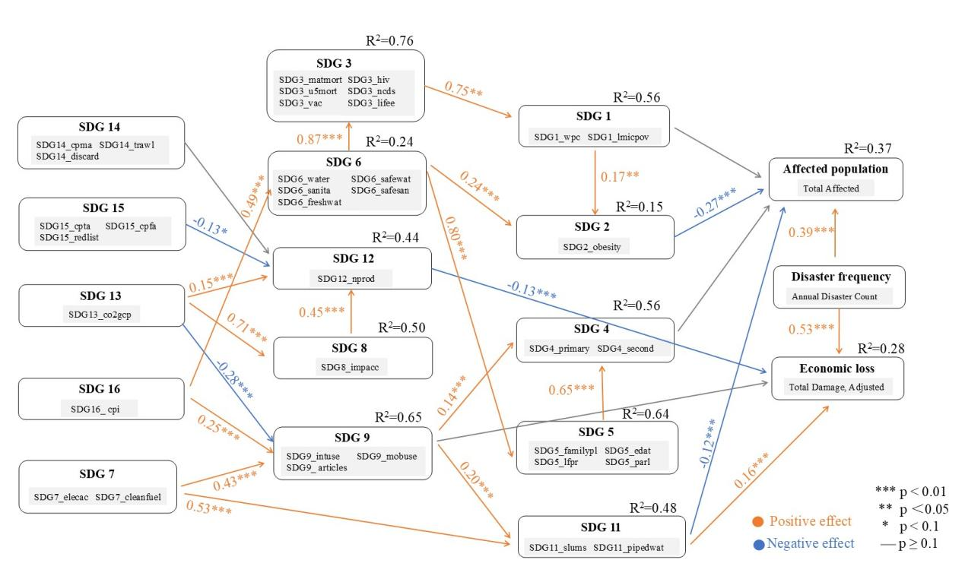
Figure 54. SEM results for all disaster loss based on SDG indicators selected at the 95% confidence level (p < 0.05) in the Asia-Pacific region

In Figure 55, the path coefficient from SDG 8 to SDG 12 became negative and statistically insignificant. Meanwhile, the direct path coefficient from SDG 13 to SDG 12 increased to 0.99. This indicated that the core driving force facilitating this sustainable industrial model and ultimately reducing economic loss (-0.16) was climate action (SDG 13).

With the inclusion of additional SDG 2 indicators, the direct effect of SDG 2 attenuated, with its coefficient dropping to -0.14 and becoming marginally significant. In stark contrast, the direct effect of SDG 11 was significantly strengthened (-0.12 to -0.19). Highly resilient urban and community infrastructure (SDG 11) served as the primary force for direct life preservation in the face of disasters.

Furthermore, Figure 55 newly incorporated SDG 17 (Partnerships for the Goals). However, the results revealed that neither the paths from SDG 17 to SDG 9 nor the paths from SDG 17 to SDG 8 were statistically significant. This indicated that partnerships and external collaboration (SDG 17) failed to translate into tangible infrastructure improvements (SDG 9) or economic resilience (SDG 8). Consequently, this suggested that local-level disaster resilience relied more heavily on internal governance and hard investments rather than external aid or cooperative frameworks.

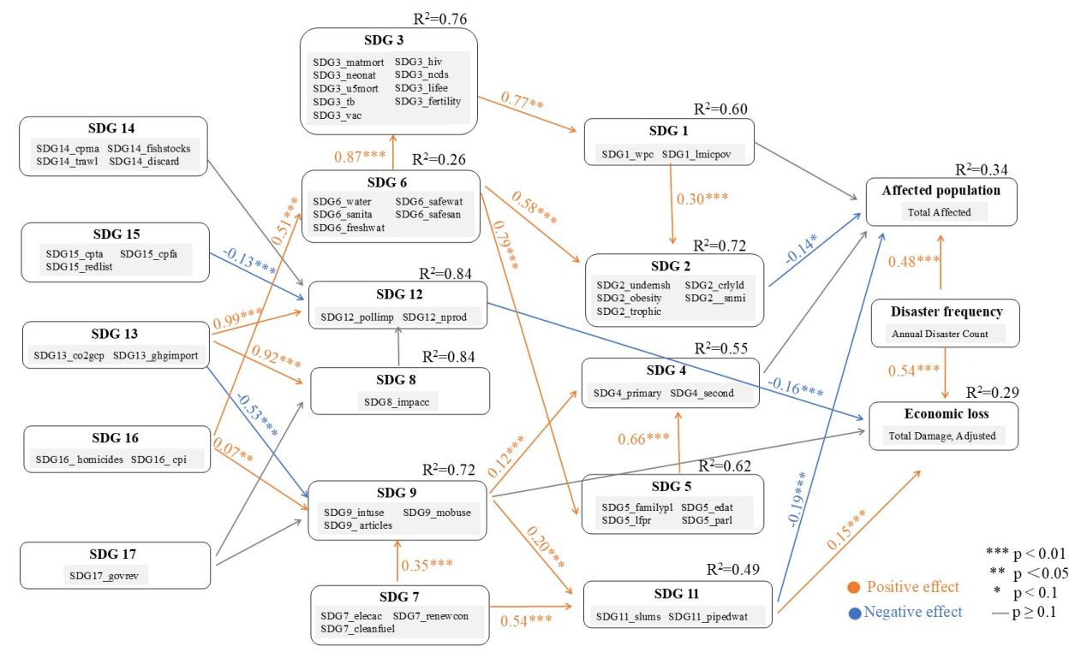
Figure 55. SEM results for all disaster loss based on SDG indicators selected at the 90% confidence level (p < 0.1) in the Asia-Pacific region

4.3.2 Earthquake
As shown in Figure 56, the path coefficient from SDG 2 (Zero Hunger) to the affected population was not statistically significant, indicating that food security did not exert a direct effect on the population affected by earthquakes. This lack of significance can likely be attributed to the sudden onset and catastrophic physical destruction characteristic of earthquakes, where the scale of human impact is predominantly dictated by structural seismic resistance and emergency response capacity rather than baseline food security.

Regarding economic loss, both SDG 12 (Responsible Consumption and Production) and SDG 6 (Clean Water and Sanitation) exhibited significant effects.

① SDG 12 → Economic loss
SDG 12 exerted a significant negative direct effect on economic loss (-0.39). This suggests that responsible consumption and production patterns not only generate long-term environmental and social benefits but also fortify macroeconomic resilience, thereby reducing economic losses caused by earthquake impacts.

② SDG 6 → (SDG 12 →) Economic loss
SDG 6 exerted a significant positive direct effect on economic loss (0.16). This result indicates that, although the development of clean water and sanitation infrastructure reflects higher levels of regional development, the accumulation and concentration of fixed assets, such as water supply networks, also increase the total amount of assets exposed to hazards, potentially leading to greater economic loss.

Simultaneously, this pathway revealed a significant indirect mechanism. SDG 6 significantly promoted the development of SDG 12 (0.44), which subsequently generated an indirect negative effect on economic loss (indirect effect = -0.17). Since the direct and indirect effects operated in opposite directions, they largely offset each other, resulting in an overall effect close to zero. This finding suggests that, although water infrastructure development increases asset exposure, its contribution to promoting sustainable consumption and production patterns can partially mitigate the associated economic loss risk.
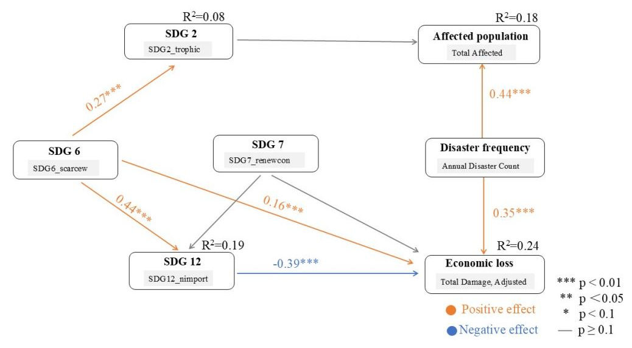
Figure 56. SEM results for earthquake loss based on SDG indicators selected at the 95% confidence level (p < 0.05) in the Asia-Pacific region

Figure 57 further incorporated the dimensions of gender equality (SDG 5) and good health and well-being (SDG 3). The results showed that SDG 5 exerted a significant positive effect on SDG 3 (0.43). However, the effect of SDG 3 on the affected population was not statistically significant. This suggests that societal-level improvements in health and well-being have a negligible impact on reducing the population affected by earthquakes. Compared with broader social development factors, building seismic resilience and emergency response capacities are likely to play more critical roles in determining earthquake-related human impacts.

③ SDG 7 → SDG 12 → Economic loss
In Figure 56, all pathways associated with SDG 7 were insignificant. However, in Figure 57, SDG 7 exhibited a significant negative effect on SDG 12 (-0.13), while its direct effect on economic loss remained insignificant. This suggests that the transition toward clean energy may create certain structural trade-offs with sustainable consumption and production systems, thereby constraining SDG 12 and indirectly increasing earthquake-related economic loss risk (indirect effect = 0.03).

④ SDG 9 → (SDG 12 →) Economic loss
Figure 57 further introduced Industry, Innovation and Infrastructure (SDG 9). SDG 9 exerted a significant positive direct effect on economic loss (0.23). This indicates that, although improvements in industrial and infrastructure development promote regional economic growth, they also increase the spatial concentration of high-value fixed assets, thereby raising asset exposure and potentially leading to greater direct economic losses during earthquakes.

Notably, SDG 9 showed a significant negative effect on SDG 12 (-0.61), suggesting that large-scale industrialization and infrastructure development may, to some extent, constrain the development of sustainable consumption and production patterns. Through this pathway, SDG 9 indirectly exacerbated economic loss risk (indirect effect = 0.15), resulting in a dual mechanism of increased loss driven by both greater infrastructure exposure and impeded sustainability transitions.
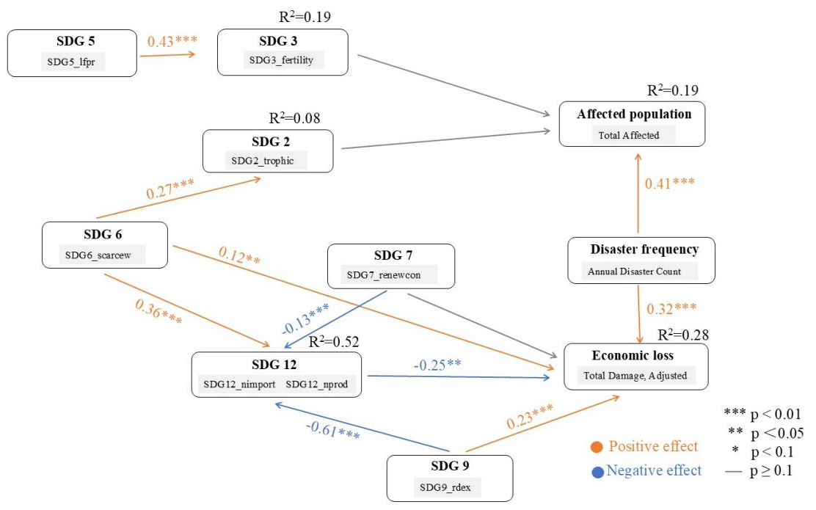
Figure 57. SEM results for earthquake loss based on SDG indicators selected at the 90% confidence level (p < 0.1) in the Asia-Pacific region

4.3.3 Flood
In terms of affected population, SDG 2 (Zero Hunger), SDG 11 (Sustainable Cities and Communities), and SDG 3 (Good Health and Well-being) exerted significant direct negative effects, indicating their roles in reducing the population affected by floods.

① SDG 16 → SDG 6 → SDG 1 → SDG 2 → Affected population
Peace, Justice and Strong Institutions (SDG 16) significantly promoted the development of Clean Water and Sanitation (SDG 6) (0.13), while SDG 6 exerted a strong positive effect on No Poverty (SDG 1) (0.82). Reduced poverty levels further enhanced regional food security and sustainable agriculture (SDG 2, 0.77). Ultimately, SDG 2 exerted a significant negative effect on the affected population (-0.28). This finding suggests that maintaining a continuous livelihood support chain encompassing water security, poverty alleviation, and food security plays an important role in reducing the population affected by flood disasters.

② SDG 7 → (SDG 9 →) SDG 11 → Affected population
Clean energy (SDG 7) not only directly enhanced the sustainability of cities and communities (SDG 11) (0.68), but also indirectly promoted SDG 11 through fostering industrial development and infrastructure construction (SDG 7 → SDG 9 = 0.46; SDG 9 → SDG 11 = 0.14). Ultimately, SDG 11 exerted a significant negative effect on the affected population (-0.26), indicating that improvements in urban sustainability and infrastructure capacity can strengthen regional flood prevention and mitigation capabilities, thereby reducing the population affected by flood disasters.

In terms of economic loss, SDG 12 (Responsible Consumption and Production) and SDG 11 (Sustainable Cities and Communities) were identified as the key variables exerting significant direct effects (Figure 28).

③ SDG 13 → SDG 12 → Economic loss
Climate Action (SDG 13) significantly promoted responsible consumption and production patterns (SDG 12, 0.55), while SDG 12 exhibited a significant negative effect on economic losses (-0.12). This indicates that high-quality industrial and production systems driven by climate action can effectively reduce economic losses caused by floods.

④ SDG 7 → (SDG 9 →) SDG 11 → Economic loss
The synergistic development of Affordable and Clean Energy (SDG 7) and Industry, Innovation and Infrastructure (SDG 9) significantly promoted Sustainable Cities and Communities (SDG 11) (SDG 7 → SDG 11 = 0.68; SDG 9 → SDG 11 = 0.14). However, SDG 11 exhibited a significant positive direct effect on economic losses (0.20). This result suggests a trade-off between urbanization and disaster losses. Although higher levels of urbanization and infrastructure development contribute to disaster prevention and population protection, they are also accompanied by the concentration of high-value assets and critical infrastructure. Consequently, increased asset exposure may lead to greater economic losses during extreme flood events.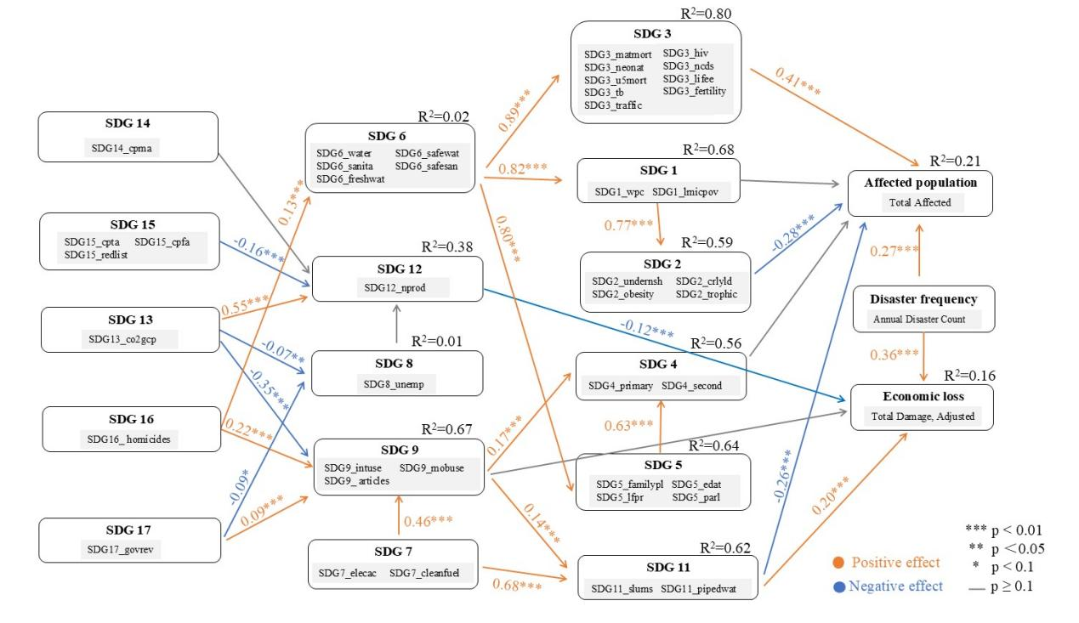
Figure 58. SEM results for flood loss based on SDG indicators selected at the 95% confidence level (p < 0.05) in the Asia-Pacific region

Compared with Figure 58, the effect of Life on Land (SDG 15) on Responsible Consumption and Production (SDG 12) changed from negative (-0.16) to positive (0.13) in Figure 59. This result indicates that improvements in terrestrial ecosystems can provide more stable ecological conditions and resource support, thereby promoting the development of sustainable production and consumption patterns.

In addition, the economic loss transmission pathways changed. In Figure 58, a complete and significant pathway existed in which Climate Action (SDG 13) reduced economic losses through promoting Responsible Consumption and Production (SDG 12). However, in Figure 59, this pathway was no longer supported because the effect of SDG 12 on economic losses failed to pass the significance test. This suggests that, under the current model specification, the direct role of green transformation in production and consumption systems in reducing flood-related economic losses remains uncertain.

Although the above pathway was no longer significant, the driving role of SDG 13 within the system was strengthened. The relationship between SDG 13 and Decent Work and Economic Growth (SDG 8) shifted from a weak negative effect (-0.07) in Figure 58 to a significant positive effect (0.92) in Figure 59. This finding indicates that climate action and high-quality economic development have established a strong synergistic relationship, allowing low-carbon transition and economic growth to advance simultaneously.
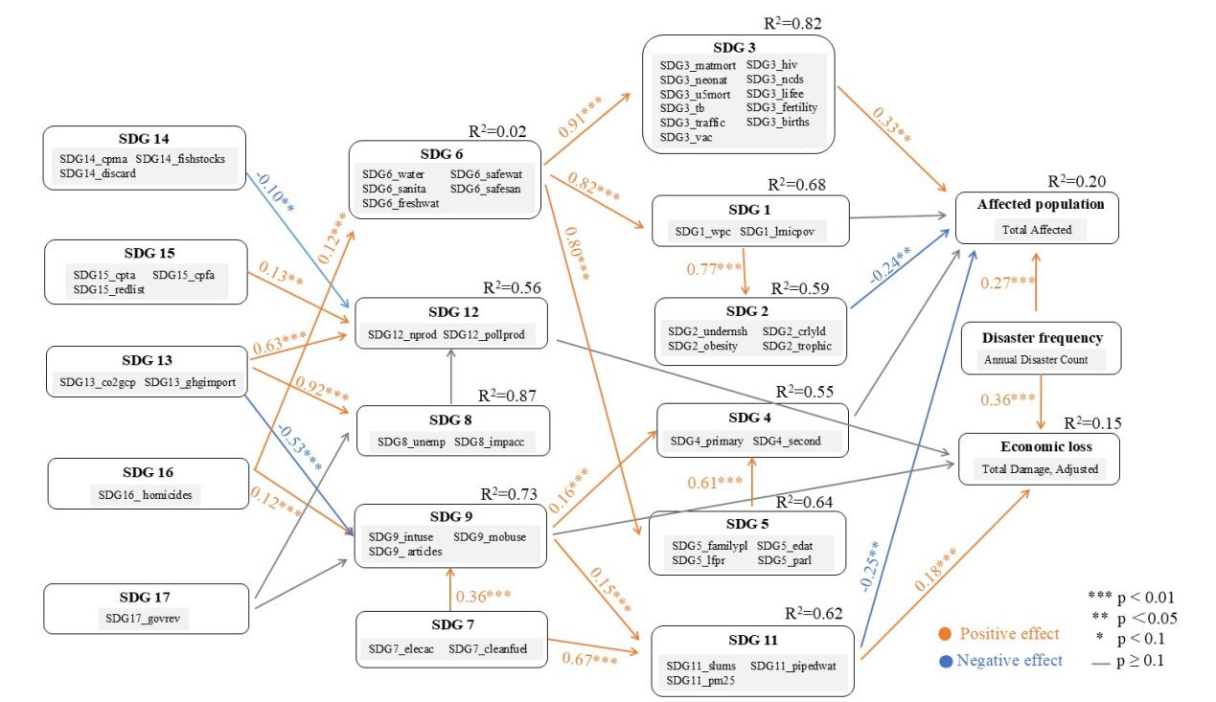
Figure 59. SEM results for flood loss based on SDG indicators selected at the 90% confidence level (p < 0.1) in the Asia-Pacific region

4.3.4 Drought
In terms of affected population, SDG 12 (Responsible Consumption and Production) and SDG 14 (Life Below Water) exerted significant direct effects, operating in opposite directions (Figure 60). SDG 12 had a significant positive effect on affected population (0.30), indicating that regions with higher production-side nitrogen emission levels and more resource-intensive production patterns experienced a larger scale of affected populations during droughts. SDG 14 exerted a significant negative effect on affected population (-0.19), suggesting that higher marine ecological sustainability could, to a certain extent, buffer the casualties caused by droughts.

In terms of economic loss, there were no statistically significant direct or indirect pathways (Figure 60). This indicated that the SDG variables primarily influenced the scale of the affected population but failed to form a stable explanatory structure for economic loss.
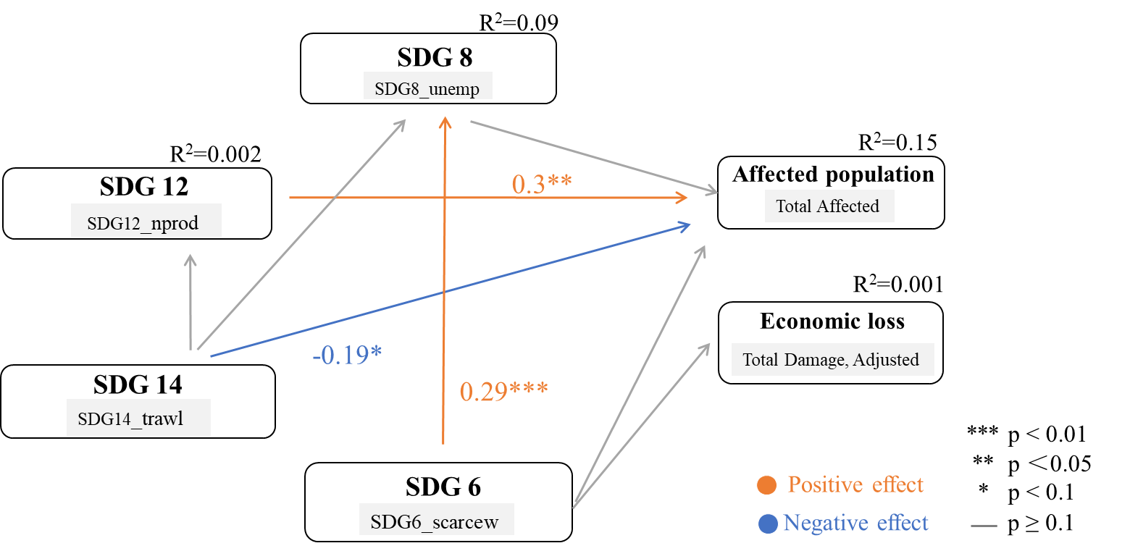
Figure 60. SEM results for drought loss based on SDG indicators selected at the 95% confidence level (p < 0.05) in the Asia-Pacific region

In Figure 61, the direct negative effect of SDG 14 (Life Below Water) on affected population became statistically insignificant, shifting instead to an indirect impact via the pathway of SDG 14 → SDG 12 (0.15). This indicated that marine ecosystems no longer directly served as a buffer against droughts; rather, they were integrated into the resource production system, with their influence primarily manifesting as a structural shaping of production patterns.

No Poverty (SDG 1) emerged as a new variable exerting a direct negative effect (-0.22). This suggested that upon the inclusion of social development indicators, the core focus for reducing drought-related affected population shifted from ecological sustainability to poverty governance capacity. Consequently, addressing social vulnerability became a more critical lever for DRR.

With the incorporation of SDG 5 (Gender Equality), a new pathway was formed: SDG 5 → SDG 8 (0.48) → SDG 1 (0.28). This demonstrated that gender equality acted as a vital driving force for improving employment, alleviating poverty, and ultimately reducing the number of people affected of droughts.

Furthermore, the newly added climate action (SDG 13) exhibited a strong path directed toward SDG 12 (0.86). This indicated that climate action began to dominate the adjustment of production structures under drought conditions. However, this adjustment was still primarily transmitted to the affected population through resource-intensive production patterns, rather than being directly translated into disaster mitigation benefits.

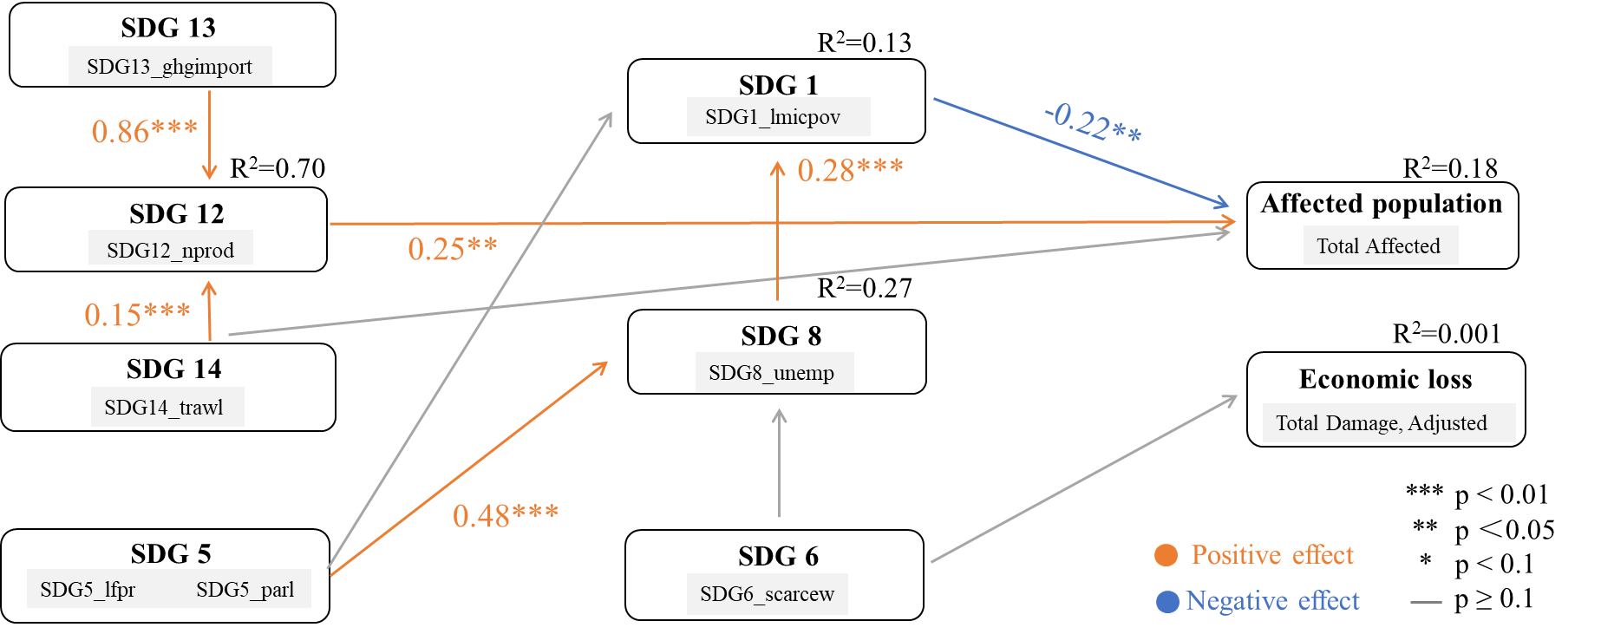
Figure 61. SEM results for drought loss based on SDG indicators selected at the 90% confidence level (p < 0.1) in the Asia-Pacific region

4.3.5 Mass Movement
In terms of affected population, SDG 12 (Responsible Consumption and Production) exerted a significant direct negative effect on affected population (-0.41) (Figure 62). This indicated that higher levels of sustainable consumption and production patterns could directly reduce the scale of the affected population. In the context of mass movement, SDG 12 served as a key protective mechanism, suggesting that alleviating pollution transfer and resource consumption pressures was inherently a crucial pathway for reducing population exposure to disasters.

Furthermore, the model revealed a clear main pathway: SDG 13 → SDG 12 → affected population. Climate action (SDG 13) significantly promoted SDG 12 (0.96), which in turn significantly mitigated affected population (-0.41). This demonstrated that climate action did not directly impact affected population; rather, it indirectly reduced the number of people affected by mass movement disaster by reshaping toward more sustainable consumption and production patterns. Consequently, this suggested that the core value of climate governance in the face of mass movement lay in driving the transformation of production systems, rather than merely focusing on direct post-disaster response.

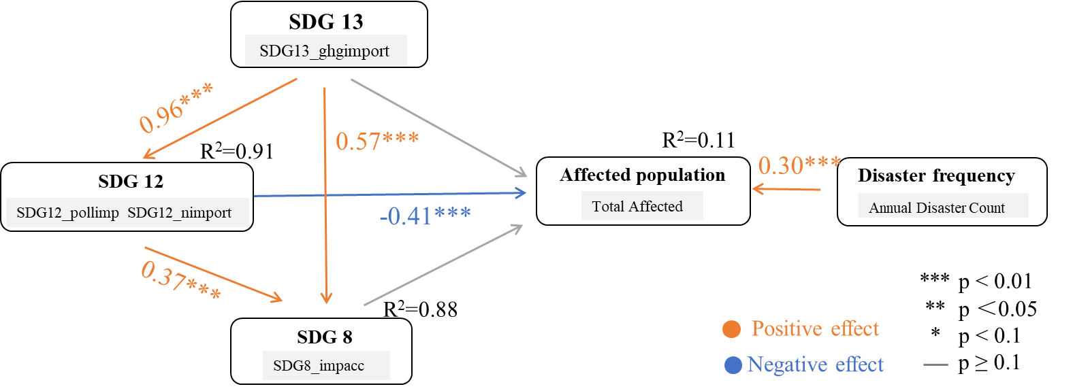

Figure 62. SEM results for mass movement loss based on SDG indicators selected at the 95% confidence level (p < 0.05) in the Asia-Pacific region

In Figure 63, climate action (SDG 13) revealed a newly added direct positive path to affected population (0.42), while continuing to robustly drive responsible consumption and production (SDG 12, coefficient: 0.96). This indicated that climate action was no longer merely a governance variable; instead, it possessed a dual role: directly increasing human exposure while indirectly mitigating disaster impacts through production transformation.

The model introduced a new pathway: SDG 8 → SDG 1 → SDG 5. SDG 8 exerted a significant negative effect on SDG 1 (-0.48), and SDG 1 positively promoted SDG 5 (0.30). This demonstrated that the mass movement model began to integrate a social governance pathway characterized by economic growth, poverty alleviation, and social equity.

Upon the inclusion of economic loss, the SDG pathways still failed to form a stable explanatory structure for economic loss. This indicated that even with increased model complexity, the SDG framework in the context of mass movement continued to primarily influence affected population rather than economic loss. Consequently, the core explanatory framework remained firmly focused on population vulnerability governance.
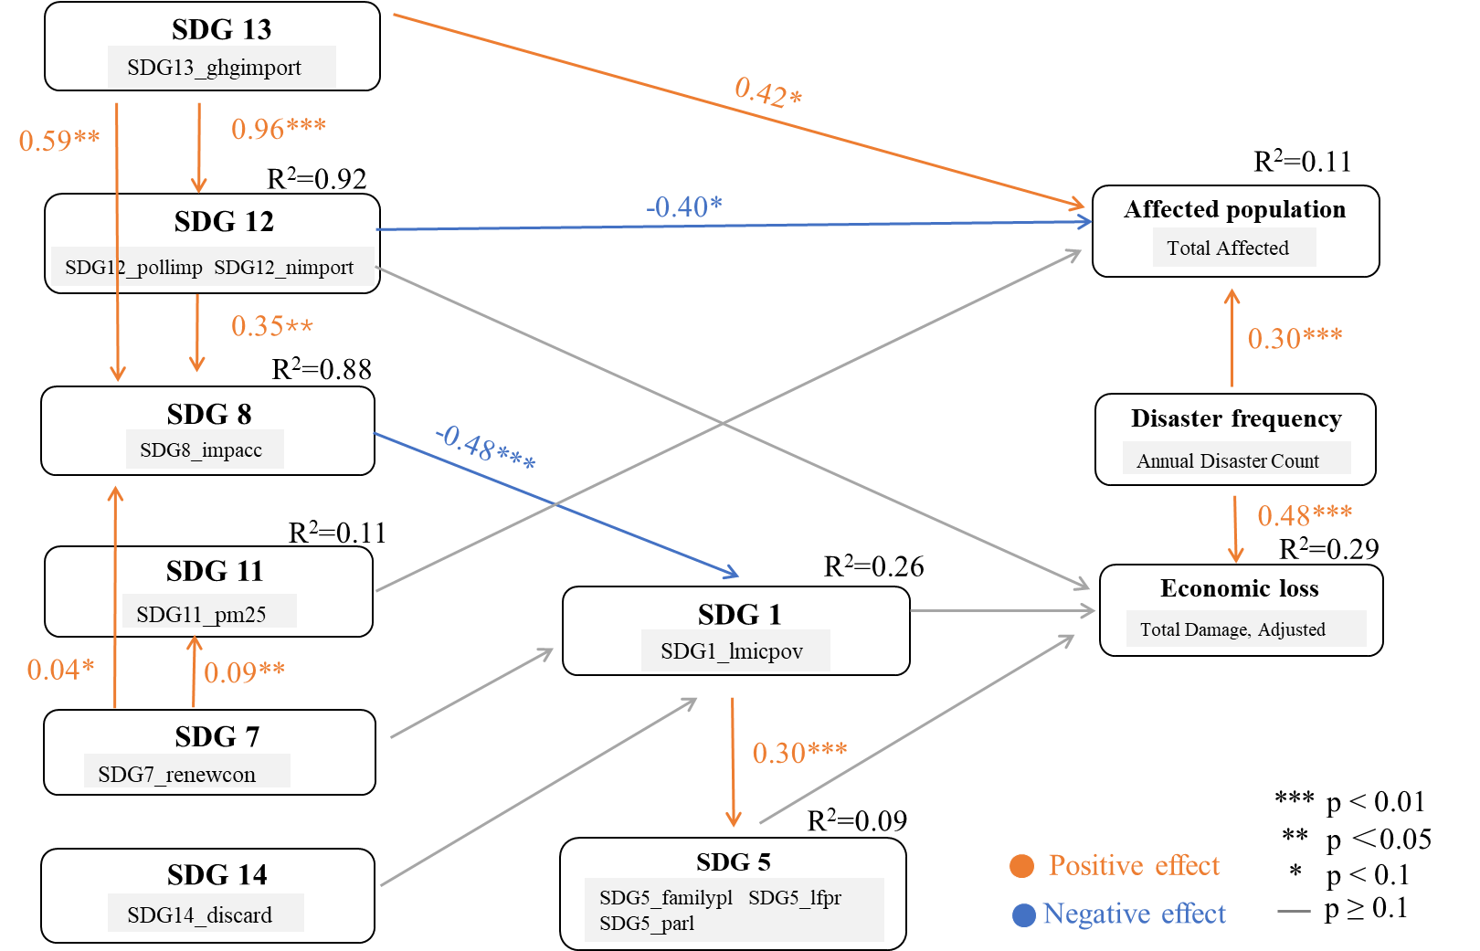
Figure 63. SEM results for mass movement loss based on SDG indicators selected at the 90% confidence level (p < 0.1) in the Asia-Pacific region

4.3.6 Extreme temperature
In terms of affected population, SDG 2 (Zero Hunger) and SDG 3 (Good Health and Well-being) exerted significant direct effects (Figure 64), but in opposite directions. SDG 2 had a positive effect on affected population (0.32), indicating that regions with higher levels of zero hunger might experience a larger scale of affected populations under extreme temperatures. Conversely, SDG 3 exerted a significant negative effect on affected population (-0.26), suggesting that higher levels of health and well-being effectively reduced the scale of the affected population. This indicated that in this model, food and agricultural systems likely acted more as a proxy for exposure levels, whereas health and well-being served as a more direct human protection factor.

- SDG 11 → SDG 3 → affected population
Sustainable cities and communities (SDG 11) significantly enhanced good health and well-being (SDG 3, 0.47), which in turn significantly mitigated affected population (-0.26). This suggested that sustainable cities and communities could indirectly reduce extreme temperature-related casualties by improving health conditions and elevating public health and life safety standards.

- SDG 2 → SDG 3 → affected population
Zero hunger (SDG 2) significantly promoted good health and well-being (SDG 3, 0.62), while SDG 3 subsequently reduced affected population (-0.26). Concurrently, however, SDG 2 directly and positively impacted affected population (0.32). This demonstrated that SDG 2 played a dual role in the extreme temperature model: on one hand, it indirectly reduced affected population by enhancing health and well-being; on the other hand, it directly increased the scale of the affected population, likely due to the concentration of agricultural activities and consequently higher population exposure.

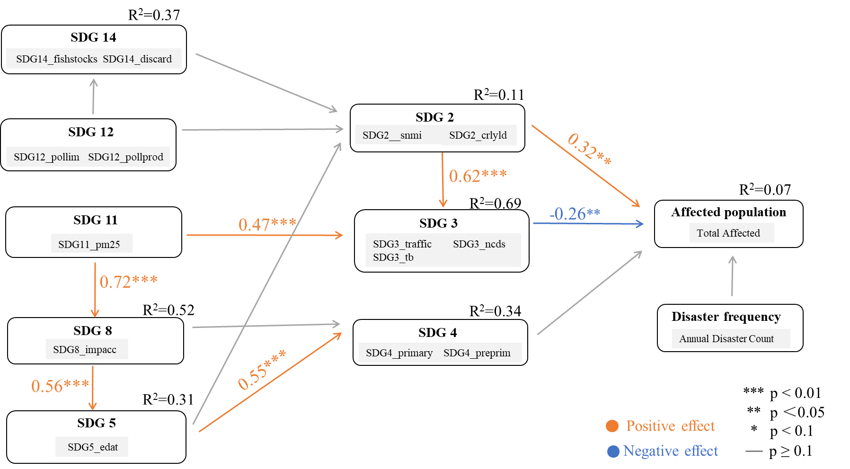
Figure 64. SEM results for extreme temperature loss based on SDG indicators selected at the 95% confidence level (p < 0.05) in the Asia-Pacific region

In Figure 65, the structure of direct effects underwent significant changes. In Figure 64, the variables directly impacting affected population were SDG 2 (Zero Hunger, 0.32) and SDG 3 (Good Health and Well-being, -0.26). In contrast, Figure 65 revealed a new direct positive effect of SDG 6 (Clean Water and Sanitation, 0.50) on affected population, while the negative effect of SDG 3 strengthened to -0.35. These results suggested that factors related to infrastructure and population aggregation were closer to the direct exposure layer than food systems.

SDG 6 not only exerted a direct positive effect on affected population (0.50) but also significantly promoted poverty alleviation (SDG 1, 0.56). This indicated that clean water and sanitation were no longer merely a social welfare variable; instead, they likely served as a proxy for regions with high population density and infrastructure concentration. Although these areas offered higher levels of basic services, they also exhibited a larger scale of affected populations during extreme temperature events due to more concentrated human exposure.

While SDG 2 directly influenced affected population in Figure 64, the path shifted to SDG 14 (Life Below Water) → SDG 2 (0.47) in Figure 65. This indicated that SDG 2 functioned more as a structural node for food, nutrition, and resources, rather than a direct factor of disaster exposure. As indicators increased, the role of SDG 2 shifted from directly impacting affected population to participating in risk formation through more complex ecological and social chains.

Furthermore, the social structural pathways expanded significantly. In addition to the original path (SDG 11 → SDG 8 → SDG 5 → SDG 4), a new pathway emerged: SDG 6/SDG 7 → SDG 1 → SDG 4. This demonstrated that quality education (SDG 4) was jointly shaped by the synergy of social development and poverty governance.
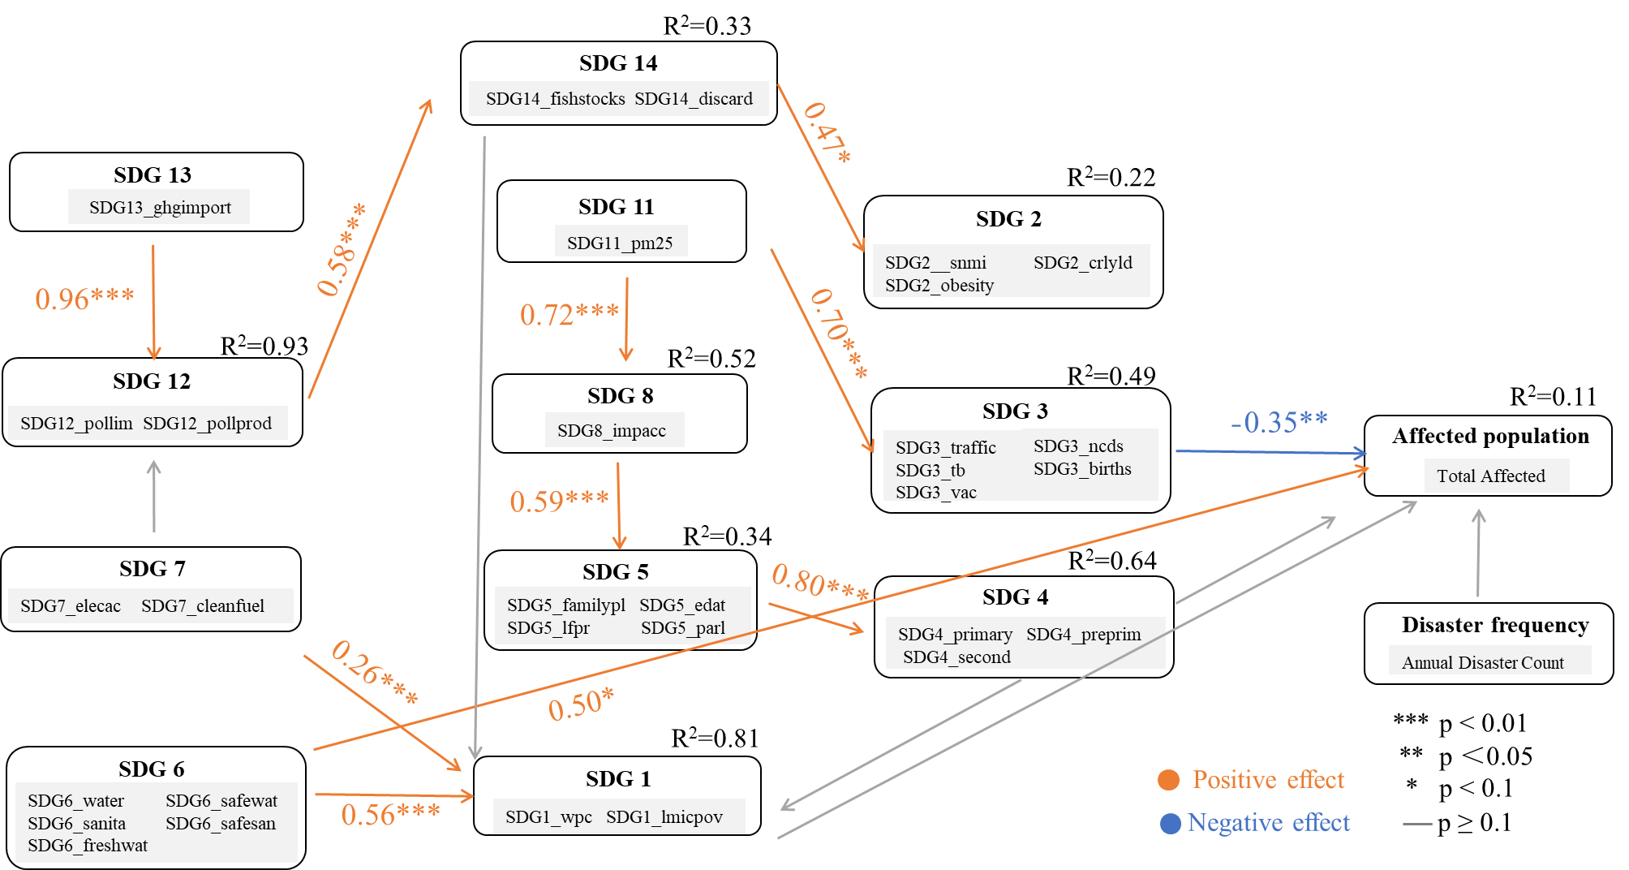
Figure 65. SEM results for extreme temperature loss based on SDG indicators selected at the 90% confidence level (p < 0.1) in the Asia-Pacific region

5. Policy Implications
The empirical analysis reveals a complex, non-linear relationship between sustainable development and DRR at the global level and in the Asia-Pacific region. While the integrated implementation of the SDGs generally reduces disaster-related affected population and economic losses, the effects are highly heterogeneous across hazard types and SDG indicators. Several SDGs exhibit dual attributes, simultaneously reducing social vulnerability while increasing physical exposure. Based on these findings, the following policy implications are proposed for integrating DRR and sustainable development in the region.

5.1. DRR implications at different spatial scales
In terms of global economic losses, whether it is the average economic loss from all disasters or the economic losses from individual disaster types such as storms, floods, and droughts, the feedback effect of the implementation of the SDGs in reducing global disaster economic losses is significantly greater than the impact of disaster economic losses on the SDGs. Overall, it is mainly a negative trade-off effect. On a global scale, as the implementation of the SDGs with the rapid development of the economy and society proceed, the exposure risk of disaster economic losses is increasing.

For the number of people affected by disasters globally, whether it is the total number of disaster-affected people or the number of people affected by floods, earthquakes, and wildfires, the feedback effect of the implementation of the SDGs in reducing the global number of disaster-affected people is significantly greater than the impact of disaster-affected people on the SDGs. Globally, the number of people affected by disasters, floods, and earthquakes are mainly characterized by positive synergy effects, while the number of people affected by wildfires is mainly characterized by negative trade-off effects. On a global scale, with the rapid development of the economy and society and the implementation of the SDGs, the overall ability of humans to resist disaster risks has been significantly enhanced, except for wildfires, which require special attention.

For economic losses in the Asia-Pacific region, whether it is the average economic loss from all disasters or the economic losses from individual disaster types such as storms, floods, and earthquakes, the feedback effect of the implementation of the SDGs in reducing the economic losses from disasters in the Asia-Pacific region is significantly greater than the impact of disaster losses on the SDGs. The overall economic losses from disasters, as well as those from storms and floods in the Asia-Pacific region, mainly show a negative trade-off effect. The impact of earthquake losses is not significant. At the regional scale of the Asia-Pacific, as the implementation of the SDGs and the rapid development of the economy proceed, the exposure risk of disaster losses is increasing.

In terms of the number of people affected by disasters in the Asia-Pacific region, whether it is the total number of disaster-affected people or the number of people affected by floods, earthquakes, and extreme temperatures, the feedback effect of the implementation of the SDGs in reducing the number of disasters affected in the Asia-Pacific region is significantly greater than the impact of disasters on the SDGs. In general, the number of people affected by disasters in the Asia-Pacific region, floods and earthquakes mainly show positive synergy effects, while the number of people affected by extreme temperatures mainly shows negative trade-off effects. At the regional scale of the Asia-Pacific, as the implementation of the SDGs with the rapid development of the economy and society proceed, the overall ability of humans to resist disaster risks has been significantly enhanced, except for extreme temperatures, which require special attention.

5.2. Leverage Foundational SDGs as Systemic Risk Buffers

Invest in foundational social infrastructure: Policies should prioritize SDG 1 (No Poverty), SDG 2 (Zero Hunger), SDG 3 (Good Health and Well-being), and SDG 4 (Quality Education) as core DRR strategies. Specifically, reducing the poverty headcount ratio (sdg1_wpc), increasing life expectancy (sdg3_lifee), and expanding pre-primary education (sdg4_preprim) yield the highest returns in reducing overall disaster-related affected populations. These are not merely social welfare goals but are critical DRR investments.

Address the key trade-offs in DRR design: Policies should address the trade-offs between SDG3 (Good Health and Well-being)/SDG9 (Industry, Innovation and Infrastructure)/SDG14 (Life below Water)/SDG15 (Life on Land) with reducing economic loss in the Asia-Pacific region. Specifically, reducing neonatal mortality rate (sdg3_neonat), reducing the mortality rate of children under 5 years old (sdg3_u5mort), increasing the population using the internet (sdg9_intuse), increasing the mean area that is protected in marine sites important to biodiversity (sdg14_cpma), increasing the mean area that is protected in terrestrial sites important to biodiversity (sdg15_cpta), increasing the mean area that is protected in freshwater sites important to biodiversity (sdg15_cpfa), increasing the red List Index of species survival (sdg15_redlist) bring the highest overall disaster economic losses. These are not merely independent social or economic or environmental goals but are vital in DRR strategies design in Asia-Pacific region.

Strengthen governance (SDG 16) as a prerequisite: The SEM results for all disasters, floods, and earthquakes demonstrate that strong institutions and effective governance (SDG 16) are not direct mitigators of loss but are essential enablers. SDG 16 robustly promotes clean water and sanitation (SDG 6) and resilient infrastructure (SDG 9). Policy efforts must therefore prioritize institutional capacity, regulatory enforcement, and emergency response coordination as the foundational layer upon which other DRR successes are built.
5.3. Address the Dual Nature of Development: Reducing Vulnerability vs. Increasing Exposure
The SEM analysis reveals a critical policy dilemma: several SDG indicators have a dual effect—they strengthen social resilience while simultaneously increasing physical exposure to hazards. Policies must explicitly manage this trade-off.

Manage the exposure effect of agricultural and health systems: The earthquake model shows that SDG 2 (Zero Hunger, proxied by nutrition) has a counterintuitive positive effect on affected population (0.14), as agricultural regions often have lower housing quality and seismic fortification. Similarly, in the flood model, SDG 3 (Good Health) directly increases the affected population (0.28), as high-health-standard regions are often densely populated river deltas. Policy implication: Achieving SDG 2 and SDG 3 must be coupled with mandatory, risk-informed land-use planning, building codes, and early warning systems. Development gains in these sectors must be hardened against hazard-specific risks.

Mitigate the economic exposure from infrastructure (SDG 9, 11): Across flood, earthquake, and total economic loss models, advancements in SDG 11 (Sustainable Cities) and SDG 9 (Infrastructure) significantly increase absolute economic loss (e.g., path coefficient of 0.17 for total economic loss; 0.21 for earthquake economic loss). Developed cities have higher asset density and supply chain value, leading to greater losses when struck. However, this is not an argument against urbanization but a call for risk-informed infrastructure investment. Policies should mandate disaster-proof design standards, enforce green building codes, and promote the spatial decoupling of critical infrastructure from high-hazard zones. Economic resilience requires not just more infrastructure, but smarter infrastructure.

5.4. Promote Climate Action (SDG 13) as an Economic Transformation Driver, Not Just Environmental Protection
The SEM results for mass movement, floods, and all-disaster economic loss reveal a powerful indirect pathway: SDG 13 → SDG 12 → Reduced Loss. Climate action does not directly reduce loss in most models; instead, it significantly drives responsible consumption and production (SDG 12), which then mitigates economic damage (e.g., -0.13 for all disasters; -0.16 for mass movement).

Integrate climate and economic policy: National and regional policies should reframe climate action as a catalyst for industrial upgrading and economic resilience, not merely a regulatory cost. Incentives for circular economy models, resource efficiency, and green supply chains (SDG 12) should be addressed to climate adaptation strategies. The findings show that climate-driven structural transformation of the economy is a highly effective, indirect pathway to DRR.

5.5. Adopt Hazard-Specific and Context-Based DRR Strategies
The analysis demonstrates significant heterogeneity across hazard types. A "one-size-fits-all" DRR approach will fail.

- For floods: Prioritize integrated water management (SDG 6) and poverty alleviation (SDG 1) to reduce affected population. For economic loss, focus on climate-driven sustainable production (SDG 13 → SDG 12) and resilient urban systems (SDG 11), while acknowledging the latter's exposure effect.

- For storms: Heavily leverage public health (SDG 3), terrestrial and marine biodiversity protection (SDG 14, 15), and internet access (SDG 9) to reduce economic losses, given the very high feedback effect (TE of 1.03 from SDGs to storm losses).

- For earthquakes: Recognize the vulnerability of agricultural communities (SDG 2) and the economic exposure from dense infrastructure (SDG 9). Policies must focus on seismic retrofitting of existing infrastructure, strict building codes for new assets, and targeted resilience programs for rural agricultural areas.

- For extreme temperatures: Address the dual pathway where SDG 2 increases affected population (0.32) but SDG 3 reduces it (-0.26). Policy must focus on public health interventions (heat action plans, cooling centers) and recognize that water infrastructure (SDG 6) can be a proxy for dense, exposed populations.

- For droughts: Shift focus from ecological buffers (SDG 14) to poverty governance (SDG 1) and gender equality (SDG 5) as the core levers for reducing affected populations. Economic loss is not well-explained by SDG indicators, suggesting the need for complementary economic modeling.

5.6. Adopt Integrated Soft and Hard Resilience Pathways
Finally, the study confirms that effective DRR requires both "hard" infrastructure investments and "soft" governance systems.

Integrate transmission pathways: Policies should explicitly design interventions that follow the transmission pathways identified in the SEM, such as:

- Life-saving pathway: SDG 16 (Governance) → SDG 6 (Water) → SDG 1 (Poverty) → SDG 2 (Food) → Reduced affected population.

- Economic resilience pathway: SDG 13 (Climate) → SDG 12 (Sustainable production) → Reduced economic loss.

- Social equity pathway: SDG 5 (Gender) → SDG 8 (Economy) → SDG 1 (Poverty) → Reduced vulnerability.

By moving beyond aggregate correlations and adopting these hazard-specific, mechanism-based policy implications, decision-makers in the Asia-Pacific region can better navigate the synergies and trade-offs between sustainable development and disaster risk reduction, fostering a truly risk-informed and resilient future.

5.7. Rethink External Partnerships (SDG 17)
The SEM results for total disaster loss (at the 90% confidence level) show that pathways from SDG 17 to SDG 9 or SDG 8 were statistically insignificant. This suggests that international partnerships and external collaboration, as currently structured, do not automatically translate into measurable improvements in infrastructure resilience or economic resilience under existing implementation mechanisms. Rather than implying that international cooperation is ineffective, the findings highlight the importance of strengthening the connection between global partnerships and local capacities.

Policies should prioritize local governance capacity (SDG 16), risk governance systems, and long-term investments in resilient infrastructure, while ensuring that local actors play a leading role in planning, implementation, and decision-making processes. In the meantime, international cooperation continues to serve a critical enabling and empowering function by supporting technology transfer, scientific collaboration, knowledge co-production, financing mechanisms, and institutional capacity building [11]. The more effective and desirable international partnerships and collaborations should therefore move beyond short-term project-based interventions, and instead focus on empowering local capacities and strengthening long-term science-policy-practice collaboration.

References
[1] United Nations Office for Disaster Risk Reduction (UNDRR), https://www.undrr.org
/implementing-sendai-framework/drr-focus-areas/disaster-risk-and-2030-agenda-sustainable-development, accessed in April, 2026.
[2] Sachs, J.D., Lafortune, G., Fuller, G., Iablonovski, G. (2025). Financing Sustainable Development to 2030 and Mid-Century. Sustainable Development Report 2025. Paris: SDSN, Dublin: Dublin University Press.
[3] Sustainable development report, https://dashboards.sdgindex.org, accessed in June, 2025.
[4] The international disaster database, Centre for research on the epidemiology of disasters, EM-DAT, https://www.emdat.be, accessed in December, 2025.
[5] Warchold, Anne, and Prajal Pradhan. "Bioeconomy and Sustainable Development Goals: How do their interactions matter?." Geography and Sustainability 6.3 (2025): 100293.
[6] Deng, H. C., Shu, Z. R., Chan, P. W., & He, X. H. (2026). Cross-height causal dependence of horizontal wind components in offshore environment: insights from transfer entropy analysis. Sustainable Energy Technologies and Assessments, 87, 104890.
[7] Ullman J B, Bentler P M. Structural equation modeling[J]. Handbook of psychology, second edition, 2012, 2.
[8] Hair J F, Ringle C M, Sarstedt M. Partial least squares: the better approach to structural equation modeling?[J]. Long range planning, 2012, 45(5-6): 312-319.
[9] Hair Jr J F, Hult G T M, Ringle C M, et al. An introduction to structural equation modeling[M]//Partial least squares structural equation modeling (PLS-SEM) using R: a workbook. Cham: Springer International Publishing, 2021: 1-29.
[10] Pal, I., Shaw, R., Dhungana, G., Mukhopadhyay, A., & Ganni, S. V. S. A. B. (2023). An overview of vulnerability and resilience building in the Asia Pacific region. Multi-Hazard Vulnerability and Resilience Building, 1-13.
[11] IRDR (2025). Disaster Risk Reduction Products and Processes: Knowledge Sharing for Place- and Context-Specific Actions. Policy Brief [Writing Team: Ruiz-Rivera, N., Garcia Ferrari, M.S., Ismail-Zadeh, A, Yang, S., Garimoi Orach C., Azahari Razak, K., Ngaira J., Lian F.]. Integrated Research on Disaster Risk, International Programme Office, Beijing, China.

